你的红线计划（red line plan）是最新的吗？  红线计划是一张关于卖酒场所的地图，其红线标出的区域是经维州赌博及酒类监管委员会批准的供酒和饮酒区域。  红线计划的副本（经维州赌博及酒类监管委员会盖章批准）必须保存在持卖酒执照的场所，以供维州赌博及酒类监管委员会的检查员或维州警方（Victoria Police）检查。  如果你没有经维州赌博及酒类监管委员会批准的副本，你可以发邮件至contact@vcglr.vic.gov.au  免费获得一份副本。  想要了解更多信息，请点击这里（here）。  www.vcglr.vic.gov.au | 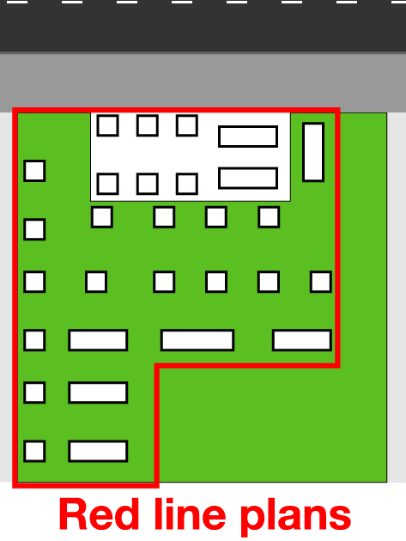
Is you red line plan up to date?

Is your red line plan up to date?

A red line plan is a map of a venue with a red line indicating the area where liquor is allowed to be supplied and consumed approved by the Victorian Commission for Gambling and Liquor Regulation (VCGLR).

A copy of the plan (stamped approved by the VCGLR) must be kept on the licensed premises and be available on request by a VCGLR Inspector or Victoria Police.

If you don’t have a copy of your approved plan, you can obtain a free copy from the VCGLR by emailing contact@vcglr.vic.gov.au
More information is available here.

www.vcglr.vic.gov.au

