在有卖酒执照的场所提供并宣传免费的水  有卖酒执照的场所必须为其顾客提供免费的饮用水。  维州赌博及酒类监管委员会鼓励你通过展示这张标语牌（poster）向顾客宣传你为他们提供水。你可以在维州赌博及酒类监管委员会网站上获得该标语牌，或者自己制作它。  切记：如果你没有供应免费的饮用水，你可能会受到高额罚款。想要阅读更多信息，请点击这里（here）。  www.vcglr.vic.gov.au | 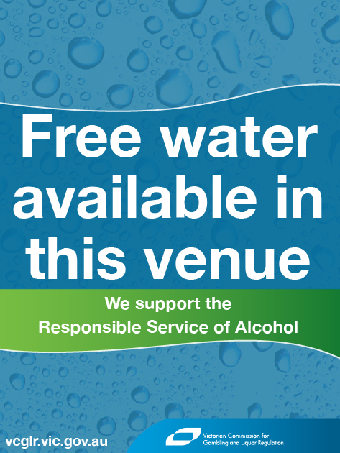
Free water in licensed venues

Provide and promote free water

Licensed venues and clubs that supply alcohol are required to provide free drinking water.

The Victorian Commission for Gambling and Liquor Regulation (VCGLR) encourages you to promote the supply of water to your members by displaying the poster, available on the VCGLR website or you can make your own.

Remember, failure to supply free drinking water could lead to substantial fines. Read more here.

www.vcglr.vic.gov.au

