Are you displaying the right posters?

你展示的标语牌是否正确？  卖酒执照持有者必须在其营业场所展示正确的标语牌，让顾客能轻而易举地看到并阅读它们。  比较你的标语牌左下角的编号和维州赌博及酒类监管委员会网站（website）上的酒类标语牌（liquor signage）网页上列出的编号，以检查你的标语牌是否正确。  你可以随时打印标语牌。这个链接（link）教你如何这么做。  www.vcglr.vic.gov.au | 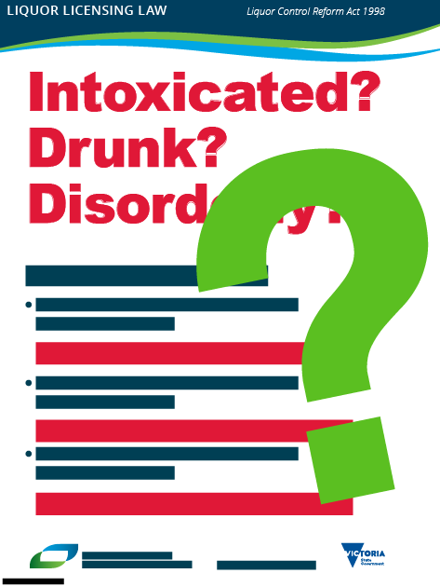

Are you displaying the right posters?

Licensed venues and clubs must display the right posters where they can easily be seen and read by members and visitors.

Check that you have the right posters by comparing the keycode located at the bottom left-hand corner of your posters, against the keycode listed on the liquor signage page of the Victorian Commission for Gambling and Liquor Regulation (VCGLR) website.

You can print the posters out anytime. Here’s the link to tell you how.

www.vcglr.vic.gov.au

