**ALH Group**

**Responsible Gambling**

**Code of Conduct**

***February 2021***

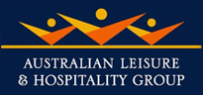

# ALH commitment to Responsible Gambling

## Preamble

We are committed to being Australia’s most responsible hotel and gaming operator - going above and beyond what legislation requires.

Our industry leading hotel and gaming charter underpins our responsible service of alcohol and gaming and is available on our website

**alhgroup.com.au**

This Code of Conduct (**Code**) has been reviewed and drafted by the ALH Group and is inclusive of the content set out in the Ministerial Direction given pursuant to s 10.6.6(1) of the Gambling Regulation Act 2003 (the Act) and effective from 1 March 2020 (the Ministerial Direction). It has been submitted to Victorian Commission for Gambling and Liquor Regulation (**VCGLR**) for publication**.** Every Victorian ALH venue that offers gambling products is required to implement the Code by the *Gambling Regulation Act 2003* (Vic).

ALH operates balanced businesses, offering patrons an overall entertainment experience including dining, drinking and gambling activities. Our goal is to ensure our hotels and clubs provide a safe and supportive environment where our customers make informed decisions about gambling and timely appropriate assistance and information is provided.

In addition to complying with all applicable legislative requirements ALH venues have also implemented a range of additional policies and initiatives to promote responsible gambling. ALH is committed to continually improving our practices and participates in many state and local government gaming working groups to assist in identifying and developing appropriate responsible gaming initiatives.

The Code is part of the induction information given to all new ALH gaming staff when they start employment. All gaming staff are familiar with the operation of the Code and all staff working in the gaming room are required to carry the pocket guide with them at all times throughout their shift.

ALH takes compliance with the Code very seriously and venues are randomly audited to ensure compliance. Staff and customers are encouraged to raise any concerns about compliance with the Code.

## ALH Group Responsible Gambling Ambassador

We have engaged David Schwarz, a well-known former professional footballer and reformed problem gambler, as its Responsible Gambling Ambassador. He provides employee education and customer awareness about the importance of “asking for help if your gambling becomes a problem”.

The program with David is based on his experience and complements the Responsible Service of Gambling training our gaming staff are required to complete. Key elements of the program include:

* Training for ALH mangers and staff to assist them in interacting with problem gamblers.
* Promoting customer awareness of responsible gambling and encouraging customers to set limits on their gambling and seek assistance if their gambling becomes a problem.
* Working with ALH management to identify further opportunities where ALH can proactively assist those who have a problem with their gambling or are at risk of developing a problem with their gambling.

David’s role also includes being available for our staff to seek advice on how best to help customers who may be experiencing difficulty with their gambling and to discuss any gambling problems staff or their family and friends may be experiencing.

David reports the number of staff members he has had contact with.

## ALH Responsible Gambling Message

1. ALH venues have a duty to take all reasonable steps to prevent and minimise harm from the operation of gaming machines, by monitoring the welfare of customers, discouraging intensive and prolonged gaming machine play and intervening when a customer is displaying behaviour that is consistent with gambling harm.

The following responsible gambling message will be displayed at the entrance to the gaming room and/or at the cashier’s station in the gaming room and at the Keno sales terminal in any venue where Keno is sold:

We are committed to providing responsible gambling. Whilst gambling is enjoyed by the majority of people responsibly, we acknowledge that problem gambling is a serious community issue and that a small proportion of customers are harmed by their gambling activities.

Our goal is to ensure we provide a safe and supportive environment, where our customers can make informed decisions about gambling and appropriate assistance and information is available.

We want our gaming facilities to be enjoyed as a social recreation by responsible individuals who choose to use them.

We actively support the promotion and encouragement of responsible gambling.

# Availability of the Code of Conduct

ALH venues will make the Code available in written form to customers in the venue upon request. The Code is also available on the ALH website:

<http://www.alhgroup.com.au/responsible-service/responsible-service-of-gaming>

A sign advising customers of the availability of the Code will be displayed at the gaming room entrance or the cashier’s station in the gaming room and at the Keno sales terminal in any venue where Keno is sold.

The Code is available in the following languages on the ALH website:

* Greek
* Italian
* Vietnamese
* Chinese
* Arabic
* Turkish
* Spanish

Any customer questions about the operation of the Code can be addressed to staff or management at the venue.

# Responsible Gambling Information

ALH venues will display responsible gambling information in a range of forms, including brochures, talkers and posters. Brochures will be made available for patrons at the cashier's desk and in venue restrooms. Talkers will be displayed next to each machine and posters will be displayed in the gaming room of each venue.

The topics covered by the responsible gambling information include:

1. How to gamble responsibly
2. How to make and keep a pre-commitment decision
3. The availability of support services
4. The payment of winnings policy
5. The prohibition on the provision of credit or the lending of money for gambling
6. The venue’s self-exclusion program

**Responsible gambling and the availability of support services**

Examples of the information on how to gamble responsibly, make and keep a pre-commitment decision and the availability of support services displayed and provided by venues include:

* 'Playing the Pokies Know the Facts' and 'YourPlay' Brochures:

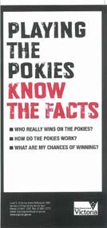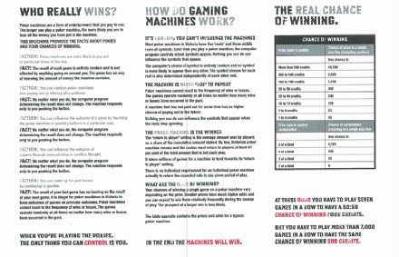

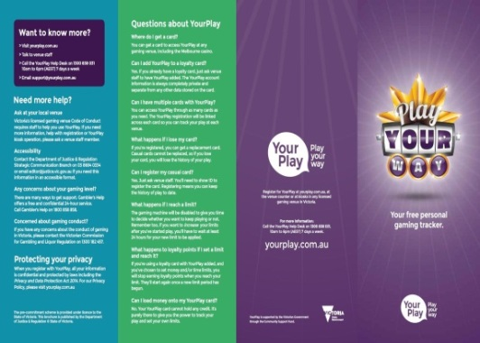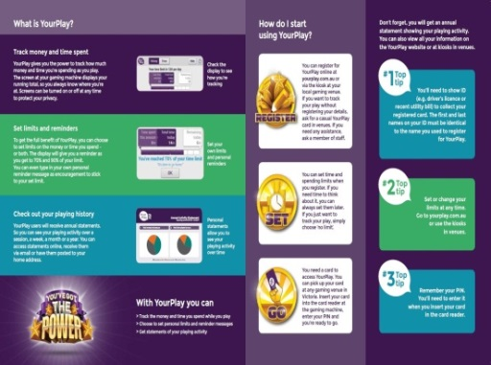

* David Schwarz responsible gambling poster



* The Gambler's Help 'Keep track of your time and money' brochure



ALH venues also provide customers with further information regarding responsible gambling, including:

* How to access the Commonwealth Government’s website ‘Money Smart’ [www.moneysmart.gov.au](http://www.moneysmart.gov.au)
* How gamblers and their families or friends can find gambling support services and information about the self-exclusion program by accessing the State Government’s problem gambling support website [www.responsiblegambling.vic.gov.au](http://www.responsiblegambling.vic.gov.au) or the national Turning Point website [www.gamblinghelponline.org.au](http://www.gamblinghelponline.org.au).

**The payment of winnings policy**

All winnings and credits totalling $2,000 or more will only be paid by cheque. The following statement will be displayed at the cashier's station of each venue:

**By law, all winnings or accumulated credits of $2,000 or more must be paid in full by cheque that is not made out to cash. These winnings cannot be provided as machine credits**

**The prohibition on the provision of credit or the lending of money for gambling**

No credit will be provided to customers for gambling. The following statement will be displayed at the cashier's station of each venue:

**The *Gambling Regulation Act 2003* prohibits this venue from providing credit to customers for playing gaming machines.**

**The venue’s self-exclusion program**

All ALH venues participate in the Australian Hotels Association (**AHA**) self-exclusion program.

A copy of the program is available at <http://assets.justice.vic.gov.au/vcglr/resources/157df81d-29c9-4b9e-84b5-e64c514b7d0d/sep_ahavictoria.pdf>

ALH venues will provide information about the self-exclusion program to customers. Customers may speak with gaming staff about the self-exclusion program or pick up a copy of the Gambler's Help self-exclusion brochure and the AHA self-exclusion business card displayed in the gaming room.

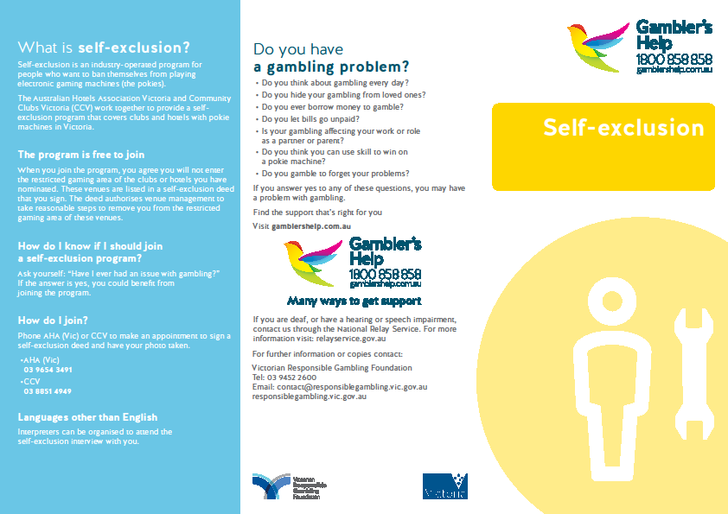

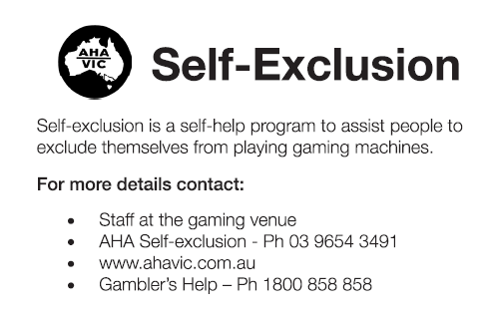

Information about the self-exclusion program is also included in the 'Our Responsible Gambling Code' Poster that will be displayed at the gaming room entrance or the cashier’s station in the gaming room.

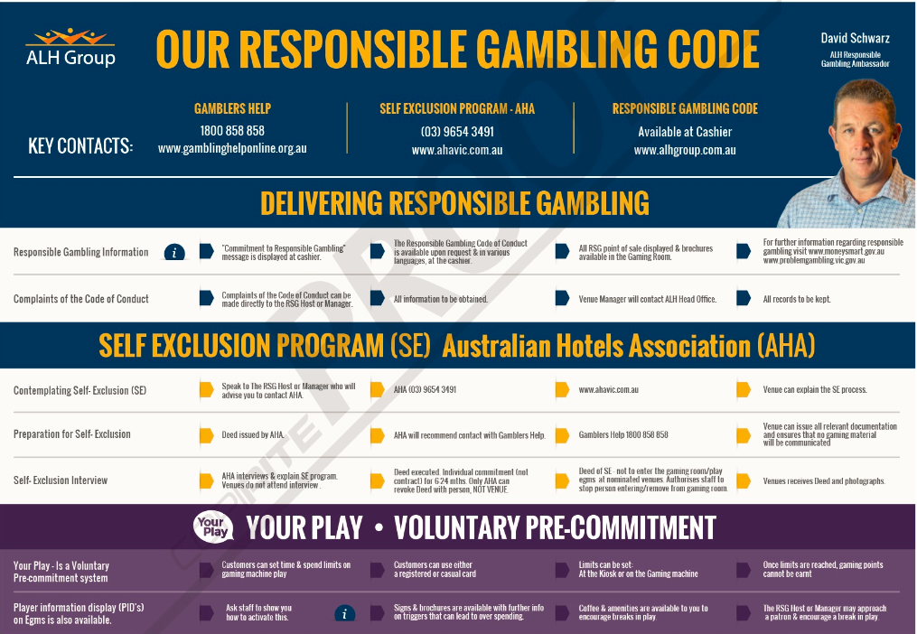

# Gambling Product Information

The rules for each Electronic Gaming Machine (**EGM**) game, including the chances of winning, are available by going to the Player Information Display (**PID**) screens on the EGM. Venue staff will be able to assist customers view the PID screen on an EGM if requested.

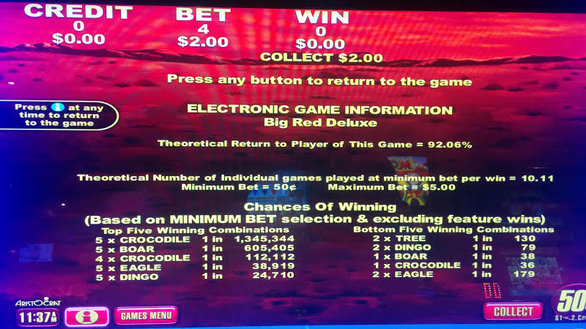

In venues where Keno is sold game guides including ‘How to Play’ instructions and game rules will be available for inspection at each Keno sales terminal.

# Customer Loyalty Scheme

ALH hotels and clubs offer a customer loyalty scheme known as 'Monty's Rewards' (**Monty's**). Customers can sign up to participate in the scheme at any ALH venue. Monty’s cards operate as voluntary pre-commitment cards and can be used in any ALH operated EGM to participate in the reward scheme and at any EGM in Victoria as part of the YourPlay voluntary pre-commitment program.

Upon joining the loyalty scheme and before issuing a Monty's card to a customer, ALH venue staff will inform the customer that the card:

* can be linked to a registered player account or can be used as a casual player card; and
* can be used to set a time limit or net loss limit or track their gaming machine play under the pre-commitment system.

Venue staff will ask the customer whether they wish to use the loyalty player card to set a time limit or net loss limit or track their gaming machine play under the pre-commitment system.

Customers who join Monty's will also be provided with a written statement that includes the following information about the loyalty scheme:

* the rules of the loyalty scheme including when gaming points can and cannot be accrued;
* how rewards are achieved;
* how rewards are redeemed; and
* how rewards expire.

Customers who participate in the loyalty scheme will be provided with an annual written player activity statement. This statement will include details of the amount of time the customer has spent playing EGMs and the net amount won or lost during the statement period by the participant on EGMs for the period when their Monty's card recorded playing activity.

Customers who have used their Monty's card to set daily limits on their gambling will not be able to earn reward points from EGM play for the remainder of the day once those limits are reached.

Customers who choose to self-exclude from an ALH gaming area will not be able to earn reward points from gaming machine play at any ALH venue.

# Pre-commitment Strategy

ALH encourages customers who play EGMs to participate in the YourPlay program and set a time and loss limit according to their circumstances.

ALH venues will display signs in the gaming room and on EGMs promoting YourPlay and recommending that customers set a limit and keep to it. Information on how to use YourPlay to track and limit the amount of time and money spent on EGMs is included in the YourPlay brochure available in the venue. Venue gaming staff will also be available to assist customers set up a pre-commitment account and set limits on their EGM playing.

# Responsible Gambling Register

Each ALH venue that provides gaming will maintain a Responsible Gambling Register (**Register**). The Register is a tool for venues to monitor their effectiveness in delivering responsible gambling and their compliance with the Code.

Gaming staff may enter information in the Register or refer the responsible gambling matter to the appropriate person so that it can be recorded. The venue manager will routinely check the Register to ensure that it is kept up to date and that any issues identified in entries in the Register have been addressed.

Examples of the types of matters that will be included in the Register are:

* customer feedback or complaints about any aspect of the Code or compliance with the Code as well as any other feedback or complaints about the operation of the EGMs at the venue;
* Self-exclusion incidents including when a self-excluded person is detected in the gaming machine area or a person wishes to revoke their self-exclusion;
* Identification of customers displaying signs of problem gambling behaviour ;
* customer requests for assistance or information associated with problem gambling;
* staff members providing a customer with information on problem gambling or self-exclusion;
* customers asked to leave the gaming machine area (for any reason for example because the customer is intoxicated);
* the provision of local problem gambling support service or Gambler’s Help Venue Support Worker training or assistance;
* staff attendance at training related to responsible gambling;
* VCGLR or Victoria Police visits to the venue; and
* any other matter that relates to the Code.

Entries in the Register will include:

(a) date and time the incident occurred;

(b) details of the incident;

(c) details of the intervention made in response to the incident;

(d) details of the customer’s response to the intervention, if known

(e) date and time the entry was recorded in the responsible gambling register; and

(f) the name of the individual, if this is provided voluntarily by that individual.

Further detail may include:

* the action taken, comments made by any relevant party or details of any follow-up action required or agreed to (for example the provision of Gamblers Help / self-exclusion information); and
* confirmation of venue sign-off of the matter by a senior representative such as the responsible gambling officer or manager.

The Register is covered by the *Privacy Act 1988* (Cth) and will be kept in a secure place that is accessible only to ALH employees, Victoria Police and VCGLR inspectors for not less than six months from the day it was recorded in the responsible gambling register

Information in the responsible gambling register may be provided to a Venue Support Worker for training and development purposes provided that information does not include the name or identifying characteristics of any customer

The Register is reviewed annually and if any specific themes occur, further training for staff may take place.

# Interaction with Customers

As part of our commitment to responsible gambling ALH venues are committed to providing consistently high levels of customer service.

ALH venues are balanced businesses that offer customers dining, drinking, entertainment and gaming activities. Part of our commitment to fostering responsible gambling is by ensuring that ALH gambling staff regularly interact with customers and encourage customers to participate in the full range of offerings at each venue. All gaming staff will interact with patrons in the gaming room and encourage patrons to take a break from playing EGMs when they have been playing for extended periods of time.

ALH venues have a nominated Responsible Gambling Officer who is always available when the venue is open. Whilst all gaming staff will be able to provide assistance to customers the Responsible Gambling Officer is the person responsible for ensuring that any customer who asks for information or assistance regarding problem gambling or self-exclusion is provided with it.

All gaming staff receives training on the self-exclusion program and other problem gambling assistance programs available from Gamblers Help as well as the behaviours that may indicate that a customer is experiencing problems with their gambling. All gaming staff will be aware of their responsibility to assist patrons both in response to direct requests for assistance and where patrons are displaying signs that their gambling is becoming a problem. A customer displaying signs of distress or unacceptable behaviour will be approached by a staff member who will offer assistance.

ALH venues will ensure that communications with customers does not:

(a) Induce a customer to enter or remain in the gaming machine area

(b) Induce gaming machine play (with the exception of communication that forms part of a loyalty program), or

(c) Reinforce or encourage fallacies or misconceptions about gaming machines, including but not limited to:

i. Telling a customer that they can make money playing a gaming machine

ii. Telling a customer that a gaming machine or gaming machine jackpot has or has not paid, or that it is due to pay, winnings

iii. Discussing luck or superstitions

iv. Telling a customer that a ‘near miss’ means the gaming machine is about to pay winnings

v. Suggesting or encouraging the belief that a spin on a gaming machine is not independent of another spin on that gaming machine

vi. Suggesting or encouraging the belief that there are strategies that a customer can use to win when playing a gaming machine (for example, increasing or decreasing the amount bet per line or number of lines on which a bet is made), or

vii. Telling a customer that they deserve to win.

This venue will take reasonable steps to ensure that communications with customer discourage intensive and prolonged gaming machine play.

With the exception of EFTPOS signage, this venue will not induce a customer to:

(a) Withdraw money, or withdraw more money, from a cash facility, or

(b) Leave this venue to obtain money, or obtain more money, to enable that customer to play, or to continue to play, a gaming machine.

This venue may however direct a customer to a cash facility when requested to do so by the customer.

Venue staff to look for signs of distress or unacceptable behaviour which may include:

* a person either gambling every day or finding it difficult to stop gambling at closing time;
* gambling for extended periods; that is, gambling for three hours or more without a break;
* avoiding contact while gambling, communicating very little with anyone else, barely reacting to events going on around them;
* making requests to borrow money from staff or other customers or continuing to gamble with the proceeds of large wins;
* displaying aggressive, anti-social or emotional behaviour while gambling.

ALH venues will:

take all reasonable steps to ensure the gaming machine area and entrances to the gaming machine area are monitored at all times gaming machines are available for play.

will take all reasonable steps to ensure that customers in the gaming machine area are regularly observed to monitor behaviour that is consistent with gambling harm.

will not encourage or induce a customer to engage in intensive or prolonged gaming machine play.

Staff will ask a customer to take a break away from the gaming machine area where an interaction has occurred and that interaction has determined that the customer is angry while gaming or has requested assistance as a consequence of their gaming.

Staff will interact with a customer who has been observed to have been playing gaming machines for a prolonged period without a break and ask that customer to take a break away from the gaming machine area.

Staff at ALH venues will interact with a customer who:

1. Has been asked to take a break and refuses to take a break away from the gaming machine area
2. Plays multiple gaming machines simultaneously, or

Reserves a gaming machine in order to play another gaming machine

This assistance may take the form of:

* providing the customer with information about Gamblers Help counselling and support services; and
* encouraging the customer to take a break from the gaming machine and offering the customer some refreshments (eg. cup of tea or coffee) in another part of the venue.

When interacting with customers, staff will always respect the customer's right to privacy.

Contacts with customers who may be at risk of problem gambling by venue staff will be recorded in the Register together with the details of any action taken. Details to be included in the Register are set out above at clause 7.

Also as part of fostering a responsible gambling environment intoxicated patrons will not be permitted to enter or remain in the gaming area.

# Interaction with staff

ALH staff is not permitted to gamble at a venue they are employed in at any time.

Part of the services provided by David Schwarz include being available to staff to confidentially discuss any problems they or their family or friends may be experiencing with their gambling.

ALH venues will display a poster advising staff of the availability of this service in the staff common area or other suitable part of the venue.

ALH venues will provides information to staff so that they are aware of their increased risk of harm from gambling. This is also included as part of the ALH advanced training course.

# Interaction with Problem Gambling Support Services

ALH venues are committed to maintaining strong links with local problem gambling support services. Venue management will meet regularly with Gambler’s Help and Venue Support Workers and together with venue staff will participate in the training programs and support services provided by Gamblers Help and Venue Support Workers.

ALH venues will ensure that staff who have day-to-day management of the operation of this venue and responsible gambling officers meet with this venue’s nominated venue support worker at least once every six months

Any meeting with or training from Gamblers Help or Venue Support workers will be recorded in the Register. The Register entry will include:

* time and date of the meeting or training;
* attendees at the meeting or training;
* topics discussed;
* outcomes / action items from the meeting;

# Customer Complaints

ALH venues have in place a process for the resolution of complaints about the content of the Code or venue compliance with the Code. Customers who have a complaint relating to the Code or the operation of the EGMs at the venue should make the complaint to the venue. Complaints can be emailed to the venue via the venue's website or made directly either in person or in writing at the venue. Venue staff will assist customers to make a complaint if requested.

Once a complaint is received it will be addressed in an efficient, fair and timely manner. All complaints will be acknowledged promptly and will be investigated sensitively and as soon as possible.

In investigating a complaint ALH or the venue manager may seek further information from the complainant or from any staff member of the venue and may also discuss the matter with ALH management. Anonymous complaints will be investigated to the extent possible.

If a complaint is substantiated, the venue manager will inform the complainant of any action that is to be taken to address the issue.

Complainants will always be informed of the outcome of their complaint. If the complaint is not investigated because it does not relate to the Code or a complaint is not substantiated following investigation the complainant will be provided with a written statement setting out the reasons for the decision.

Details of all complaints and any subsequent investigation will be maintained in the Register and information about the complaint will be provided to the VCGLR if requested.

If a complainant does not agree with the venue's decision on the complaint the matter may be referred to the Institute of Arbitrators and Mediators Australia (IAMA).

To refer the matter either party can go to IAMA’s web site (www.iama.org.au), download a Dispute Resolver form, and then submit this completed form with the relevant fee to the IAMA. The mediator / arbitrator will then contact both parties to facilitate a resolution. These forms are also available at this venue.

Note: Complaints sent to this independent body for resolution may be expensive. All parties are urged to attempt to resolve the matter at the venue level before going to professional mediation.

# Prohibition on Gambling by Minors

Gambling by minors is prohibited.

Signs will be displayed at every gaming room entrance banning minors from entering the room. All venue staff share the responsibility for asking for proof of age if they are uncertain whether a customer is at least 18. If relevant verification cannot be produced, the customer must be asked to leave the gaming room.

In venues where Keno is offered outside the Gaming room, signs stating that the use of the Keno selling terminal by minors is prohibited will be displayed at each terminal. ALH staff will also monitor the Keno selling terminals to help ensure that minors do not use the terminals.

# Gambling Environment

ALH recognise that extended intensive playing of gaming machines is a significant risk factor for problem gambling.

Consistent with the commitment to regular interaction with customers and to encouraging customers to use YourPlay to track and limit how much money and time they spend on EGMs outlined in clauses 6 and 7 above, customers will be encouraged to take regular breaks from gaming machine play.

This encouragement may take the form of direct interaction with venue staff or announcements regarding other offering or events underway in the venue, for example announcing:

* that morning tea is now available;
* a member’s draw; or
* the commencement of activities such as morning melodies, trivia contests or live entertainment

ALH venues will ;

* not encourage a customer to play multiple gaming machines simultaneously.
* will take all reasonable steps to discourage a customer from reserving a gaming machine in order to play another gaming machine in the gaming machine area.
* During the opening hours of food and beverage facilities outside the gaming machine floor, this venue will ensure that a customer can order and be served food and beverage without having to enter the gaming machine area.
* may offer a customer seated at or playing a gaming machine food or beverage provided it is offered as part of an interaction with that customer.

Clocks are also displayed in all major areas of the venue including at the cashiers desk in the gaming room and on each gaming machine. Staff will mention the time when making any announcements about venue activities.

# Responsible Gambling Officer

Responsible Gambling Officers have been appointed at ALH venues.

A responsible gambling officer will be available in the gaming machine area at all times gaming machines are available for gaming.

ALH venues will display prominently in the gaming machine area a notice advising that a responsible gambling officer is available for assistance at all times.

ALH venues responsible gambling officer will take all reasonable steps to:

(a) Monitor the gaming machine area and ensure compliance with the Act, regulations and this code

(b) Ensure that staff record responsible gambling incidents and interventions in the responsible gambling register

(c) Observe customers who display behaviour that is consistent with gambling harm and provide assistance as necessary

(d) Provide advice to staff about gambling harm and how to respond to signs of gambling harm, and

(e) Respond to customer enquiries and complaints about the supply of gambling in the approved venue.

ALH venue’s responsible gambling officer will complete prescribed responsible service of gambling training.

# Financial Transactions

ALH venues will not cash cheques from customers. A sign stating this will be displayed at the cashier’s station in the gaming room.

Winnings below $2,000 from gaming machines can be paid by cash and/or cheque. By law all of the winnings or accumulated credits of $ 2,000 or more must be paid out entirely by cheque, which cannot be made out to cash. These winnings or accumulated credits cannot be provided as machine credits.

# Responsible Advertising and Promotions

Advertising of EGM gambling products outside of a gaming area is prohibited in Victoria.

All advertising and promotions related to gambling undertaken within the gaming area by or on behalf of an ALH venue must comply with the advertising code of ethics adopted by the Australian Association of National Advertisers (available at <http://aana.com.au/content/uploads/2014/05/AANA-Code-of-Ethics.pdf>)

Each prospective advertisement and promotion will be checked against a checklist developed from the AANA Code of Ethics to ensure compliance.

ALH will ensure that any advertising or promotional materials will:

* not be false, misleading or deceptive about odds, prizes or the chances of winning;
* have the consent of any person identified as winning a prize prior to publication;
* not be offensive or indecent in nature;
* not create an impression that gambling is a reasonable strategy for financial betterment; and
* not promote the consumption of alcohol while purchasing gambling products.

# Review of the Code

The operation and effectiveness of the Code is reviewed annually.

The review of the Code will look at both the relevance and effectiveness of the measures and standards required by the Code and ALH venue compliance with the Code. The review process will include an opportunity for feedback from all relevant stakeholders, including venue staff, customers and problem gambling support services. Stakeholders are involved in an annual survey to review the Code, which forms part of the annual review.

Where possible, improvements in the Code or in venue practices are identified and will be considered as part of the review process. Following the Code review, a report will be prepared for the VCGLR and any required revisions to the Code will be submitted to the VCGLR for publication. Upon publication from the VCGLR a revised Code will be implemented as soon as practicable.

Any changes required of a particular venue will be implemented as soon as possible and will be recorded in the venue’s Responsible Gambling Register.

**Appendix-Definitions**

**Definitions**

Code administrator refers to (Australian Leisure and Hospitality Group) who have prepared and administer this code.

Interaction means measured assistance based on a case-by-case assessment by venue staff. The interaction may take the form of:

* Encouraging the customer to consider food or beverage offers available at the venue which would allow a break in play from the gaming machine
* Offering the customer some refreshments (i.e. tea or coffee) in a quieter, more private part of the gaming venue where the customer has the opportunity to request appropriate support information in a confidential manner
* Assisting the customer with travel arrangements in order to depart the venue
* Providing customer with information on gambling support, and
* Explaining how the self-exclusion program works and providing information on how to access the program.

**Loyalty program** means a ‘loyalty scheme’ as defined in section 1.3 of the Act.

**Responsible gambling officers** describe staff appointed to assist the venue operator:

* Minimise gambling harm in the venue, and
* Ensure compliance with all responsible gambling regulatory and code requirements
* Respond to staff and customer enquiries about the supply of gambling in the venue.

**Responsible Gambling Register** describes a log located in the gaming area, that venue staff have access to record responsible gambling related interactions with customers.

**Venue Support Workers** describes staff from the Gambler's Help Venue Support Program. These staff assists venues in fulfilling responsibilities such as:

* Identifying and responding to patrons displaying signs of problem gambling
* Raising awareness among venue staff about, and encouraging referrals to Gambler's Help services, self-exclusion programs and other community support services
* Meeting the requirements of their Responsible Gambling Codes of Conduct
* Creating and maintaining responsible gambling environments
* Ensuring their completion of the required Responsible Service of Gaming (RSG) training.

**Disclaimer**

Any legislative changes impacting on this code do not render this code as invalid. Any State or Federal legislation or regulatory arrangements take precedence over the contents of this cod