Instructions to apply for an outdoor temporary limited licence – privately-owned outdoor areas
The VCGLR has introduced a streamlined approach towards licensing outdoor areas as a result of government directions encouraging the use of outdoor spaces by the hospitality industry.
This approach relates to applications for temporary limited licences for privately owned areas that existing licensees wish to use that are not normally licensed.
All applications must be made by permanent liquor licence holders, and only authorise the supply of liquor when patrons are seated and food is available for purchase.
This is a step by step instruction guide to assist you in applying for an outdoor temporary limited licence.
If you are applying for two outdoor area temp licences in order to use the privately-owned outdoor area for more than three months, this guide applies to both of these applications.
Note: The content on the applications system states limitations that do not apply in this situation, for example limiting to a small number of events. This would normally apply, however due to present circumstances they do not when applying for outdoor trading in this circumstance. Due to the need to implement this approach as quickly as possible changes to the system that recognise this have not been made.
Prior to starting your application, you should ensure you supply the below documents. There will be a delay in processing your application if not all documents are provided.
- A plan of the outdoor area
- If the land is not owned by you, a lease or evidence of right to use the outdoor area.

Step one: Open the online temporary limited licence application portal (link)
Step two: Click the “Apply now” button at the bottom of the screen as highlighted in the image below:
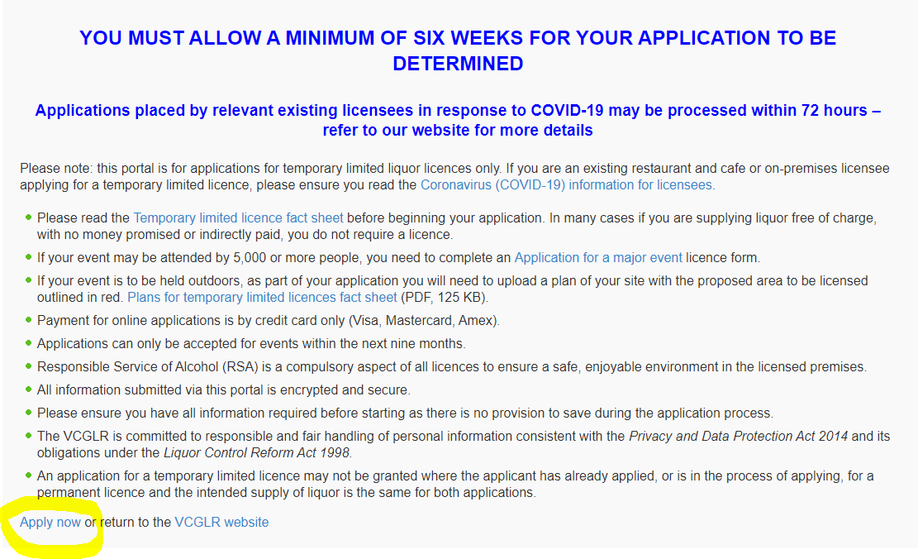
The below screen will appear.
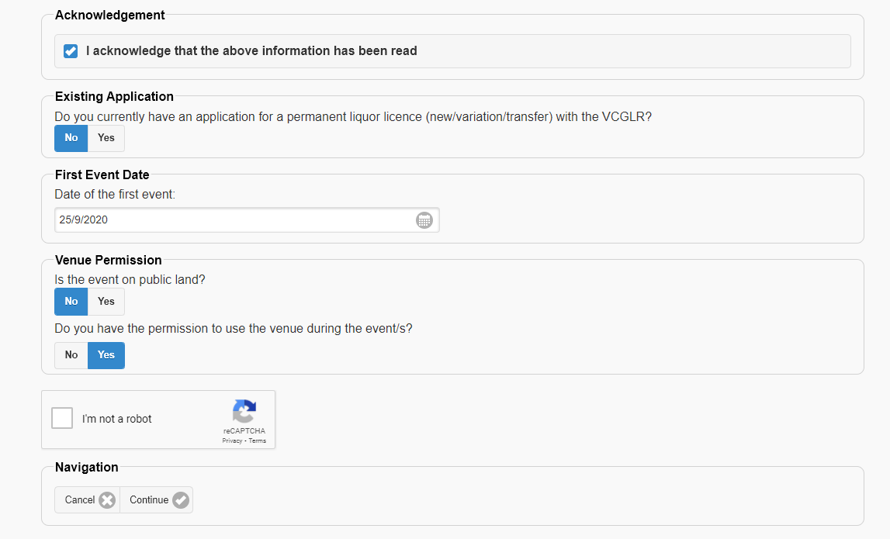
Step three: Complete the following steps:
- read the content at the beginning of the page and then click the “Acknowledgement”
- click “No” on the box regarding existing applications
- enter the first date you wish to supply liquor in the outdoor area
- Under “Venue permission”, click “No” as the land being used is privately owned and then “Yes”. You must have permission to use the land
- Click the “I’m not a robot” button and, if required, solve the captcha.
- Click Continue
Step four: Click “Yes” and then enter your licence number. If you do not do so assessment of your application will be delayed. After this, click continue.
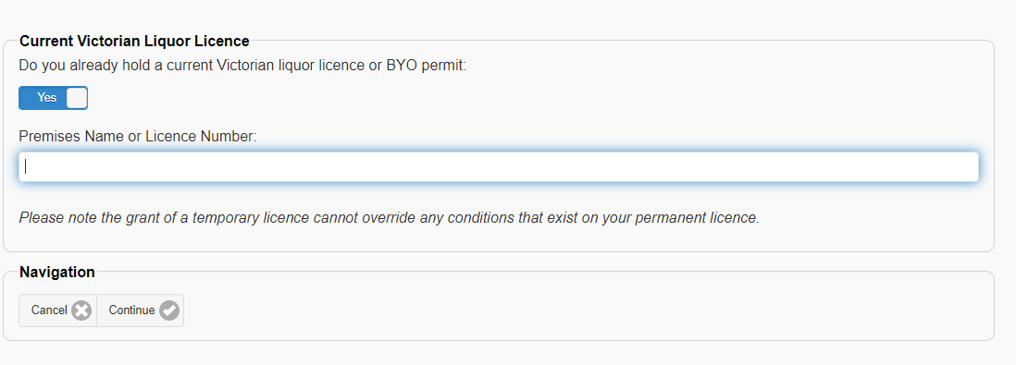
Step five: Select the licensee of the permanent licence that is most relevant, and then confirm that you are either a director or the individual.
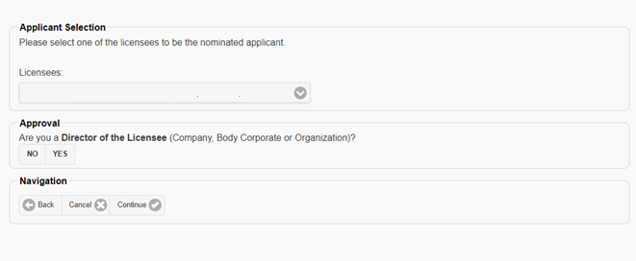
Step six: As shown below, this page will auto-fill with details we have on record. Please fill in any gaps and check all information is correct. If you find incorrect information, please update this.
Select the relationship you have to the applicant and then click continue.
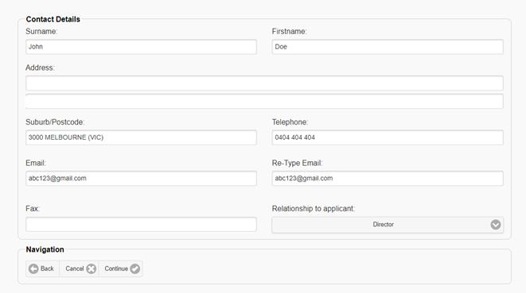
Step seven: Enter the details regarding the outdoor area. Please be as specific as possible when describing the location and ensure the address is correct. Click continue.
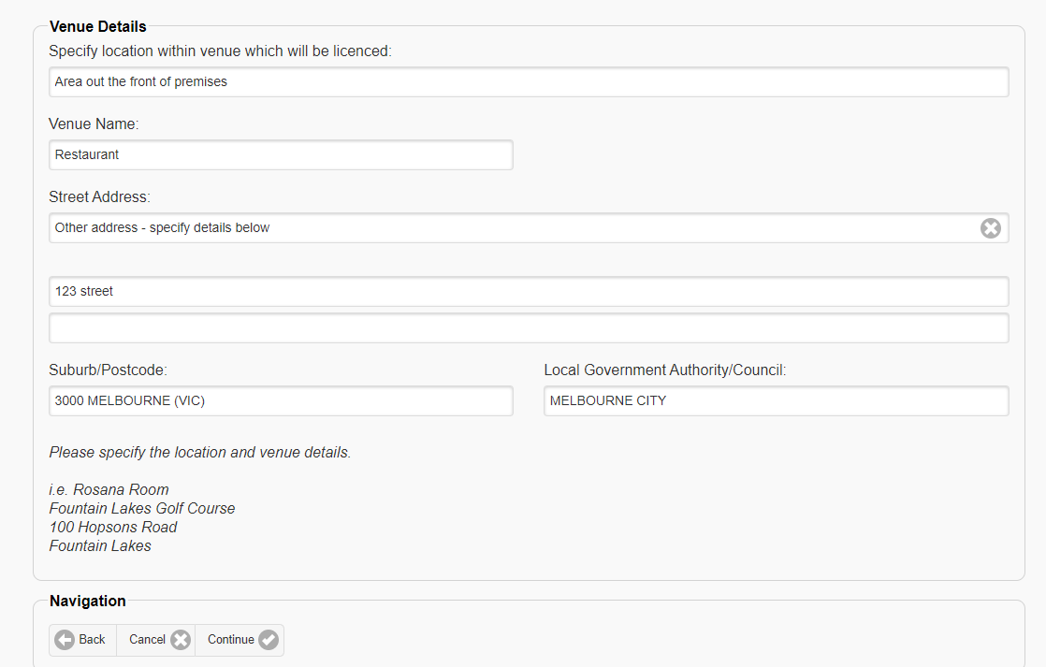
Step eight: Select “Temporary extension of permanent licence”, and then click continue. This will allow you to provide the required information later in the application process. If you select another event type this may delay the assessment of your application. 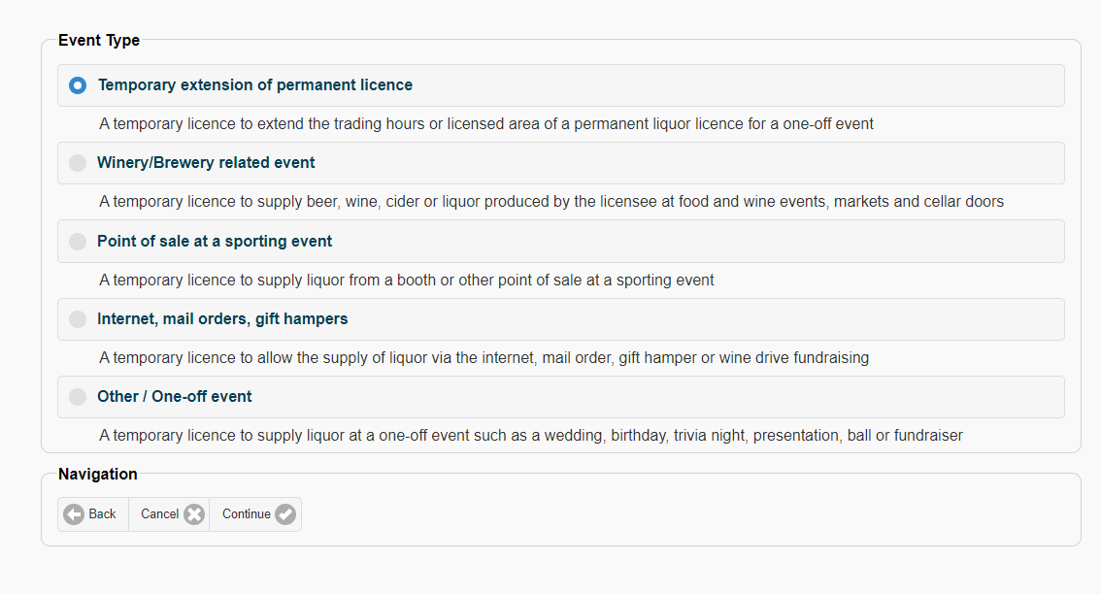
Step nine: As shown below, select No, No and then Yes. Please note that the trading hours in this policy are required to be less than what appears on your permanent licence.
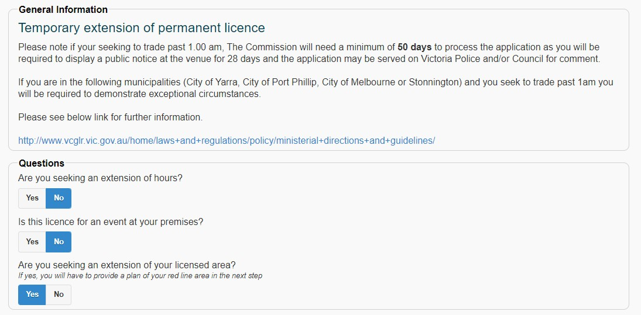
Scroll further down the page to the section titled “Event Occurrences”.
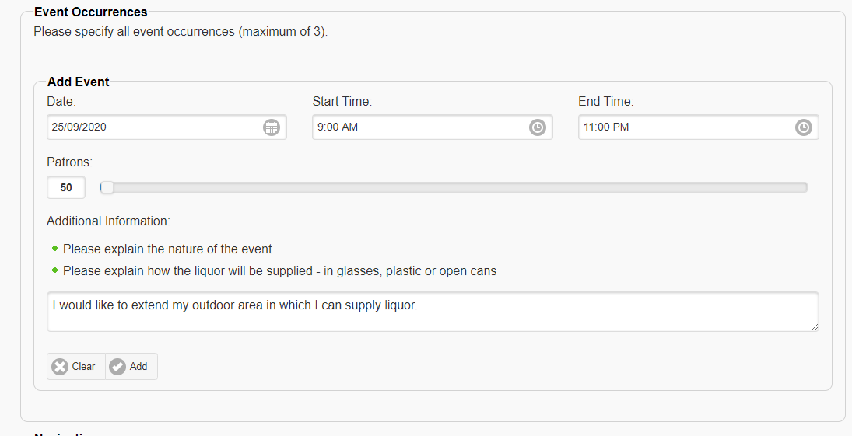
In this section, please add a date for the first day you intend to supply liquor. This event must be on the same day as the event date supplied earlier. When completing this page consider the following:
- You must include trading hours. If you wish to trade after 11pm, your application will be served on Victoria Police and your local council for comment, which will delay the processing of your application. Trading hours must also be less than those of your permanent licence.
- You must enter a patron capacity - this should be set to 50. Please be aware that any patron capacity endorsed on a licence does not override, or ensure compliance with, government regulations in regards to social distancing If you do not include trading hours or a patron capacity, you will not be able to proceed in your application.
Step ten: In the “additional information” section please explain that you are applying for an outdoor trading area and, if you are applying for two licences in order to trade for more than three months, please state this and whether it is your first or second application. When you are making your second application, please make reference to your first application reference number, which will be a number in the format 21-XXXXXX.
And then click the “Add” button.
- If you are a BYO permittee, and in addition to the outdoor area you also wish to supply liquor within the red-line plan associated with your BYO permit, please indicate so at this stage.
After an event has been added press continue. The screen will ask you to confirm that the event is only for one (or however many you entered) events – please ignore this and click continue.
Step eleven: Attach your evidence of right to use the area (if required) and your plan of the area. Click continue.
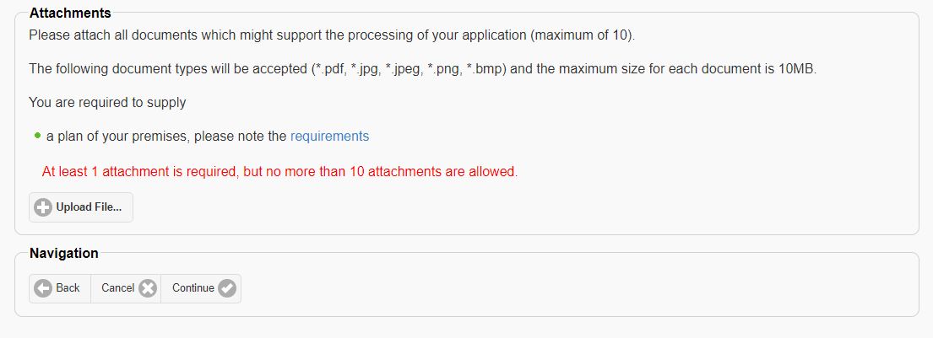
Step twelve: Once you have uploaded your documents you will be asked to complete a declaration. Please ensure you everything you have provided is accurate then submit your application.
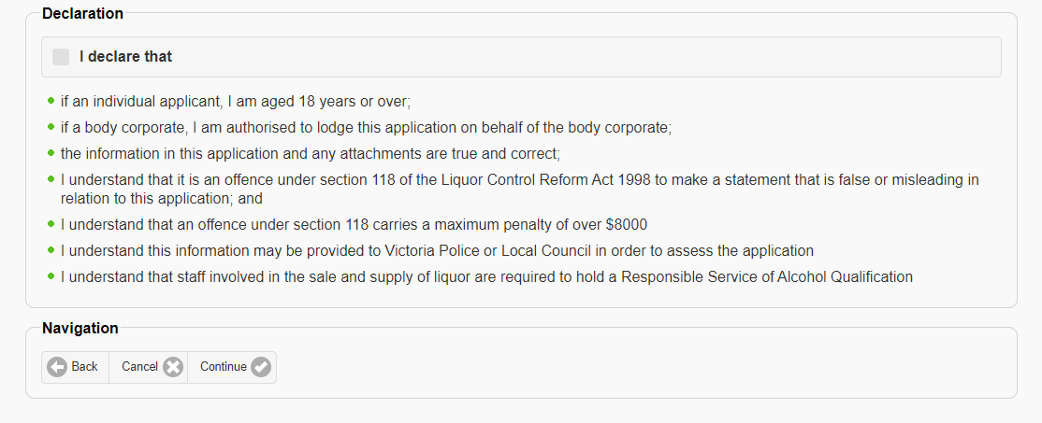
Once your application is submitted, we will endeavour to process your first application within five business days. This period of time may be longer if further documents or information is required. If this is the case, the VCGLR will contact you.
If you are making a second application, this may take eight weeks or longer to process and determine. This is the result of the requirement that this application be served on Victoria Police and local councils, as well as being publicly displayed. You will however be able to use, if granted, the licence from your first application in that time period. The VCGLR will contact you regarding when you should publicly display your application.

