(Venue Name)

Responsible Gambling Code of Conduct

October 2020

VERSION 1.5

Frontier Hospitality Co Operative Responsible Gambling Code of Conduct

EGM Gaming Venue Responsible Gambling Code of Conduct

Venue commitment to Responsible Gambling

This message is displayed at the entrance to the gaming room and/or at the cashier’s station in the gaming room:

This venue is committed to providing the highest standards of customer care and responsible gambling. Our Responsible Gambling Code of Conduct describes how we do this.

The Venue Operator has a duty to take all reasonable steps to prevent and minimise harm from the operation of gaming machines in the approved venue, including by monitoring the welfare of gaming machine players, discouraging intensive and prolonged gaming machine play and intervening when a person is displaying behavior that is consistent with gambling harm.

Responsible gambling means that consumers exercise a rational and sensible choice based on knowledge and their particular circumstances. It means a shared responsibility with collective action by the gambling industry, government, individuals and communities.

Availability of the Code of Conduct

This Code will be made available in written form, including in major community languages, to customers upon request. A sign advising customers of this is displayed at the gaming room entrance or the cashier’s station in the gaming room.

The Code will also be available on the venue’s website including in community languages. (Applies only where the venue has a website)

Languages will include:
  - Greek
  - Italian
  - Vietnamese
  - Chinese
  - Arabic
  - Turkish
  - Spanish

Responsible Gambling Information

This venue displays responsible gambling information in a range of forms, including brochures, posters and Electronic Gaming Machine (EGM) on-screen Player Information Displays (PIDs).

- The payment of winnings policy is as follows:

By law, all winnings of accumulated credits that are cashed out of a gaming machine of $2,000 or more must be paid in full by cheque that is not made out to cash. These winnings cannot be provided as machine credits.

- The prohibition on the provision of credit for gambling

The Gambling Regulation Act 2003 prohibits this venue from providing credit to customers for playing gaming machines

- This venue offers a self-exclusion program. Customers may speak with the Responsible Gambling Officer/Duty Manager or pick up a copy of the self- exclusion program brochure displayed in the gamingroom.

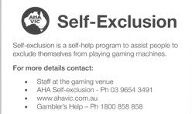

- Further information regarding responsible gambling, including how to access the Commonwealth government’s website Money Smart www.moneysmart.gov.au or similar government ‘money management’ website.

Gambling Product Information

The rules for each Electronic Gaming Machine (EGM) game, including the chances of winning, are available by going to the Player Information Display (PID) screens on the machine. Information on how to view the PID screens is available from a member of staff and/or by reading the Player Information Display (PID) brochure, available within the gaming room.
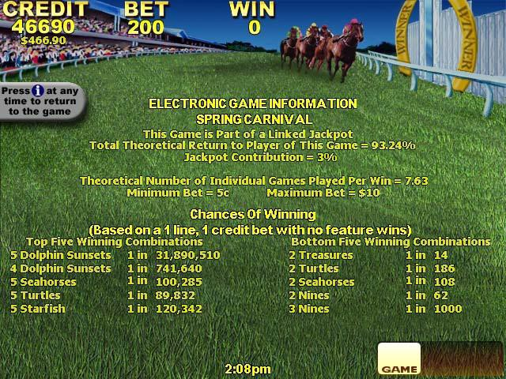

Pre-commitment Strategy

This venue encourages customers who play EGMs to set a time and money limit according to their circumstances. Signs in the gaming room and on EGMs recommend that customers set a limit and keep to it.

All EGMs at this venue enable a player to track the time and amount of money spent during a session of play. Information on how to activate session tracking is available from venue staff and in the Yourplay brochure displayed in the venue.
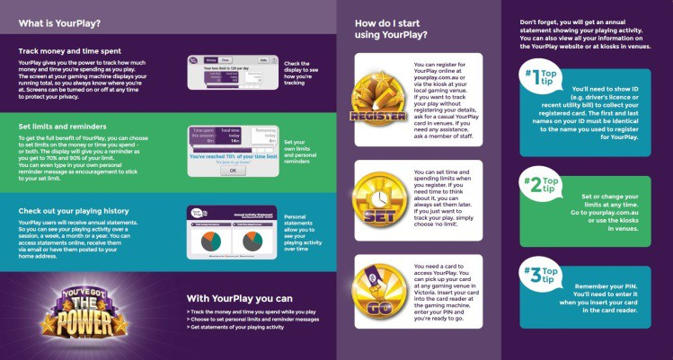

Interaction with Customers

The staff at this venue are committed to providing consistently high levels of customer service, including being constantly aware of their customers and the venue’s responsibility towards Responsible Gambling.

This venue has a nominated Responsible Gambling Officer/Gaming Duty Manager who is always available when the venue is open.

A person who approaches a staff member for information about problem gambling services or shows signs of having a problem with their gambling will be directed to the Responsible Gambling Officer/Gaming Duty Manager for help.

A customer displaying signs of distress or unacceptable behavior will be approached by a staff member who will offer assistance. These signs may include, but not be limited to a person

  - self-identifying as a problem gambler;
  - displaying aggressive, anti-social or distressed behavior while gambling ;
  - making requests to borrow money from staff or other customers or continuing to gamble with the proceeds of largewins;
  - gambling every day over an extended period of time - that is, gambling for three hours or more without a break;
  - avoiding contact while gambling, communicating very little with anyone else, barely reacting to events going on around them.

In these circumstances, staff may offer appropriate assistance based on the particular circumstances, e.g.,

  - speaking with the customer and encouraging them to take abreak;
  - offering the customer some refreshments (e.g., cup of tea or coffee) in a quieter, more private part of the gamingvenue;
  - offering to co-ordinate travel arrangements away from thevenue.

Contacts with customers by the Responsible Gambling Officer are recorded in a Responsible Gambling Register and include action taken. This register is covered by the Privacy Act.

Interaction with customers – communication with Gamblers

    - A venue operator must ensure that communications with customers do not:
      - Induce a person to enter or remain in the gaming machine area;
      - Induce gaming machine play (with the exception of communication that forms
Frontier Hospitality Co Operative Responsible Gambling Code of Conduct

5
part of a lawful loyalty scheme): or

      - Reinforce or encourage facilities or misconceptions about gaming machines, including but not limited to:
        - Telling a person that he or she can make money playing a gaming machine;
        - Telling a person that a gaming machine or gaming machine jackpot has or has not paid, or that it is due to pay, winnings;
        - Discussing luck or superstitions;
        - Telling a person that a ‘near miss’ means that the gaming machine is about to pay winnings;
        - Suggesting or encouraging the belief that a spin on a gaming machine is not independent of another spin on a gaming machine;
        - Suggesting or encouraging the belief that there are strategies that a person can use to win when playing a gaming machine (for example, increasing or decreasing the amount bet per line or number of lines on which a bet is made); or
        - Telling a person that he or she deserves to win.
    - A venue operator must take reasonable steps to ensure that communications with customers discourage intensive and prolonged gaming machine play.
    - With the exception of EFTPOS signage, a venue operator must not induce a person to:
      - Withdraw money, or withdraw more money, from a cash facility; or
      - Leave the approved venue to obtain money, or obtain more money, to enable that person to play, or continue to play, a gaming machine.
    - A venue operator may however direct a person to a cash facility when requested to do so by a customer.

Interaction with customers – signs of distress

    - A venue operator must take all reasonable steps to ensure the gaming machine area and entrances to the gaming machine area are monitored at all times gaming machines area available for gaming.
    - A venue operator must take all reasonable steps to ensure that customers in the gaming machine area are regularly observed to monitor behavior that is consistent with gambling harm.
    - A venue operator must not encourage or induce a person to engage in intensive or prolonged gaming machine play.
    - A venue operator is expected to ask a person to take a break away from the gaming machine area where an interaction has occurred and that interaction has determined that the person is angry while gaming or has requested assistance as a consequence of their gaming.
    - A venue operator is expected to interact with a person who has been observed playing gaming machines for a prolonged period without a break and ask that person to take a break away from the gaming machine area.
    - A venue operator is expected to interact with a person who:
      - Has been asked to take a break and refuses to take a break away from the gaming machine area;
      - Plays multiple gaming machines simultaneously; or
      - Reserves a gaming machine in order to play another gaming machine.

Customer Loyalty Scheme Information

  - This provision in our Responsible Gambling Code of Conduct applies only if the venue has a loyalty scheme that is a loyalty within s.1.3 of the Gambling Regulation Act. Such a loyalty scheme is characterised by

    - player expenditure tracking; and
    - rewards based on that expenditure.

  - We do not permit self-excluded persons to remain in or join the loyalty scheme.

Upon joining the venue loyalty scheme or as soon as practicable thereafter, information will be provided in a written statement that includes
    - the rules of the loyalty scheme; and
    - how rewards are achieved; and
    - how rewards are redeemed; and
    - how rewards expire.

Participating customers will be informed about any benefits they have accrued as part of the loyalty scheme via a written statement on a periodic basis (at least annually) as determined by the venue.

Gaming Venue Staff

** Venue to select one option Either
8.1 Employees of this venue are not permitted to gamble here at any time, including playing gaming machines, keno, wagering or purchasing lottery tickets.

Or
  - Employees of this venue are not permitted to play a gaming machine on a rostered day of work at the venue where the staff member is employed.

  - A venue operator must provide information to staff so that they are aware of their increased risk of harm from gambling.

Plus, in addition to either of the above alternatives
Each year responsible gambling professional development sessions for staff are held in conjunction with the local Gambler’s Help service. Information about responsible gambling and problem gambling support services is in the package received by staff members when they start employment.

The venue will assist any staff member who indicates they may have a gambling problem by ensuring they are given information about problem gambling and the support services available. The employee’s right to privacy will be respected and any such matters will not be recorded in the register.

Problem Gambling Support Services

This venue is committed to maintaining strong links with local problem gambling support services. Senior staff from this venue will meet regularly with the local Gambler’s Help and Venue Support Workers. Some examples of how we shall connect with Gambler’s Help and Venue Support Workers are
  - holding regular (at least annual) staff training session, run by the local Gambler’s Help service;
  - conducting regular management meetings between the Venue Operator / Manager and the Gambler’s Help service/Venue Support Workers.

Details of these meetings will be kept in a Responsible Gambling Register. The meeting details must include
  - time and date of the meeting;
  - attendees at the meeting;
  - topics discussed;
  - outcomes/ action items from the meeting;
  - next meeting date.
A venue operator is expected to ensure that staff who have day-to-day management of the operation of the approved venue and responsible gambling officers meet with the venue’s nominated venue support worker at least once every six months.

Customer Complaints

A customer with a complaint about the operation of this Code of Conduct should make it in writing directly to the venue management. All complaints will be checked by the venue manager to make sure that they are about the operation of this Code. Complaints about customer service or machine operations should go directly to the venue manager / staff on duty. Venue staff will assist customers with this process if asked.

Complaints will be investigated sensitively and as soon as possible. Complaints will be resolved in the following way
  - all complaints will be acknowledged promptly;
  - if it is decided not to investigate the complaint as it does not relate to the operation of the code, the customer will be informed of thereasons;

  - during the investigation the Venue Manager may seek information from the staff member concerned on the subject of the complaint;
  - the Venue Manger will seek to establish whether the customer has been treated reasonably and in accordance with this Code;
  - if the complaint is substantiated, the Venue Manager will inform the customer of the action that is to be taken to remedy the problem;
  - the customer will always be informed of the outcome of thecomplaint;
  - complaint details will be maintained in the Responsible Gambling Register;
  - information about the complaints will be provided to the VCGLR if requested.

If a complaint cannot be resolved at the venue, it goes for resolution to the Institute of Arbitrators and Mediators Australia (IAMA). Either party involved in the complaint may contact the IAMA. To initiate a complaint, either party can go to IAMA’s web site (www.iama.org.au), download a Dispute Resolver form, and then submit this completed form with the relevant fee to the IAMA. The mediator / arbitrator will then contact both parties to facilitate a resolution.
Note: Complaints sent to this independent body for resolution may be expensive. All parties are urged to attempt to resolve the matter at the venue level before going to professional mediation.

Documentation regarding all complaints against the code must be maintained in the Responsible Gambling Register for access by the VCGLR as required.

Minors

Gambling by minors, including the sale of gambling products and services to minors is prohibited. Signs are located at every gaming room entrance banning minors from entering the room. All staff share the responsibility for asking for proof of age if they are uncertain whether a customer is at least 18. If relevant verification cannot be produced, the customer must be asked to leave the gaming room.

The Gambling Environment

Customers will be encouraged to take regular breaks from gaming machine play. This encouragement may take the form of an announcement such as
  - Announcing that morning tea is now available;
  - Announcing a member’s draw;
  - The commencement of activities such as morning melodies.
•

Clocks are in all major areas of the venue so customers know time is passing. In the normal course of their duties staff will interact with customers as opportunities arise. This can have the effect of
breaking up intensive or extended periods of EGM play.

  - A venue operator must not encourage a person to play multiple gaming machines simultaneously.
  - A venue operator must take all reasonable steps to discourage a person from reserving a gaming machine in order to play another gaming machine in the gaming machine area.
  - During the opening hours of food and beverage facilities outside the gaming machine floor, a venue operator must ensure that a person can order and be served food and beverage without having to enter the gaming machine area.
  - A venue operator may offer a person seated at or playing a gaming machine food or beverage provided it is offered as part of an interaction with that person.

Responsible gambling officer

  - A venue operator must nominate responsible gambling officers for its approved venue(s).
  - A responsible gambling officer must be available in the gaming machine area at all times gaming machines are available for gaming.
  - A venue operator must display prominently in the gaming machine area a notice advising that a responsible gambling officer is available for assistance at all times.
  - A responsible gambling officer must take all reasonable steps to:
    - monitor the gaming machine area and ensure compliance with the Act, regulations and this code;
    - ensure that the staff record responsible gambling incidents and interventions in the responsible gambling register;
    - observe customers who display behavior that is consistent with gambling harm and provide assistance as necessary;
    - provide advice to staff about gambling harm and how to respond to signs of gambling harm; and
    - respond to customer enquiries and complaints about the supply of gambling in the approved venue.
  - A responsible gambling officer must complete prescribed responsible service of gambling training, if any.

Responsible Gambling Register

  - A venue operator must establish and maintain a responsible gambling register and must ensure that details of all responsible gambling incidents and interventions are recorded in this register, including:
    - date and time the incident occurred;
    - details of the incident;
    - details of the intervention made in response to the incident;
    - details of the customers response to the intervention, if known;
    - date and time the entry was recorded in the responsible gambling register;

and
    - the name of the individual, if this is provided voluntarily by that individual.
  - A venue operator must retain the information in the responsible gambling register for not less than six months from the day it was recorded in the responsible gambling register.
  - A venue operator must provide a copy of the responsible gambling register to the Victorian Commission for Gambling and Liquor Regulation on request.
  - A venue operator may provide information in the responsible gambling register to a Venue Support Worker for training and development purposes provided that the information does not include the name or identifying characteristics of any person.

Financial Transactions

This venue does not cash cheques from customers.

A sign stating this is displayed at the cashier’s station in the gaming room.

Winnings below $2,000 from gaming machines at this venue can be paid by cash and/or cheque. By law all of the winnings or accumulated credits of $ 2,000 or more must be paid out entirely by cheque, which cannot be made out to cash. These winnings or accumulated credits cannot be provided as machine credits.

A Prize Payment Register is maintained in the gaming room.

Advertising and Promotions

Unaddressed advertising of Electronic Gaming Machine (EGM) gambling products is prohibited in Victoria.

All advertising undertaken by or on behalf of this venue will comply with the advertising code of ethics adopted by the Australian Association of National Advertisers. (http://www.aana.com.au/pages/codes.html)

Each proposed advertisement and promotion will be checked against a checklist developed from the AANA Code of Ethics to ensure compliance.

Further, prior to publishing, management will review all advertising and promotional material to ensure that our advertising and promotions will
  - not be false, misleading or deceptive about odds, prizes or the chances of winning;
  - not be offensive or indecent in nature;
  - not create an impression that gambling is a reasonable strategy for financial betterment;
  - not promote the consumption of alcohol while purchasing
Frontier HospitalitgyaCmobOlpinegraptirvoedRuecsptso;nsible Gambling Code of Conduct
11

  - not, in any publication, identify any person winning a prize without their express consent.
Frontier Hospitality Co Operative Responsible Gambling Code of Conduct
12

Implementation of the Code

The Code is part of the induction information given to all new staff when they start employment. Staff members have received training about its purpose, contents and procedures.

Matters raised by staff or customers about the Code should go to the Responsible Gambling Officer/Duty Manager forattention.

Staff members who effectively implement and adopt the practices in the Code will be recognised by venue management.

Review of the Code

This Code is reviewed annually to ensure that it complies with the Gambling Regulation Act and any Ministerial Directions. The operation and effectiveness of the Code for the preceding 12 months will also be reviewed at this time. The review seeks feedback from all relevant stakeholders, including venue staff, customers and problem gambling support services.

Required changes to the venue’s practices will be noted and then implemented where possible. Any changes will be recorded in the venue’s Responsible Gambling Register.

