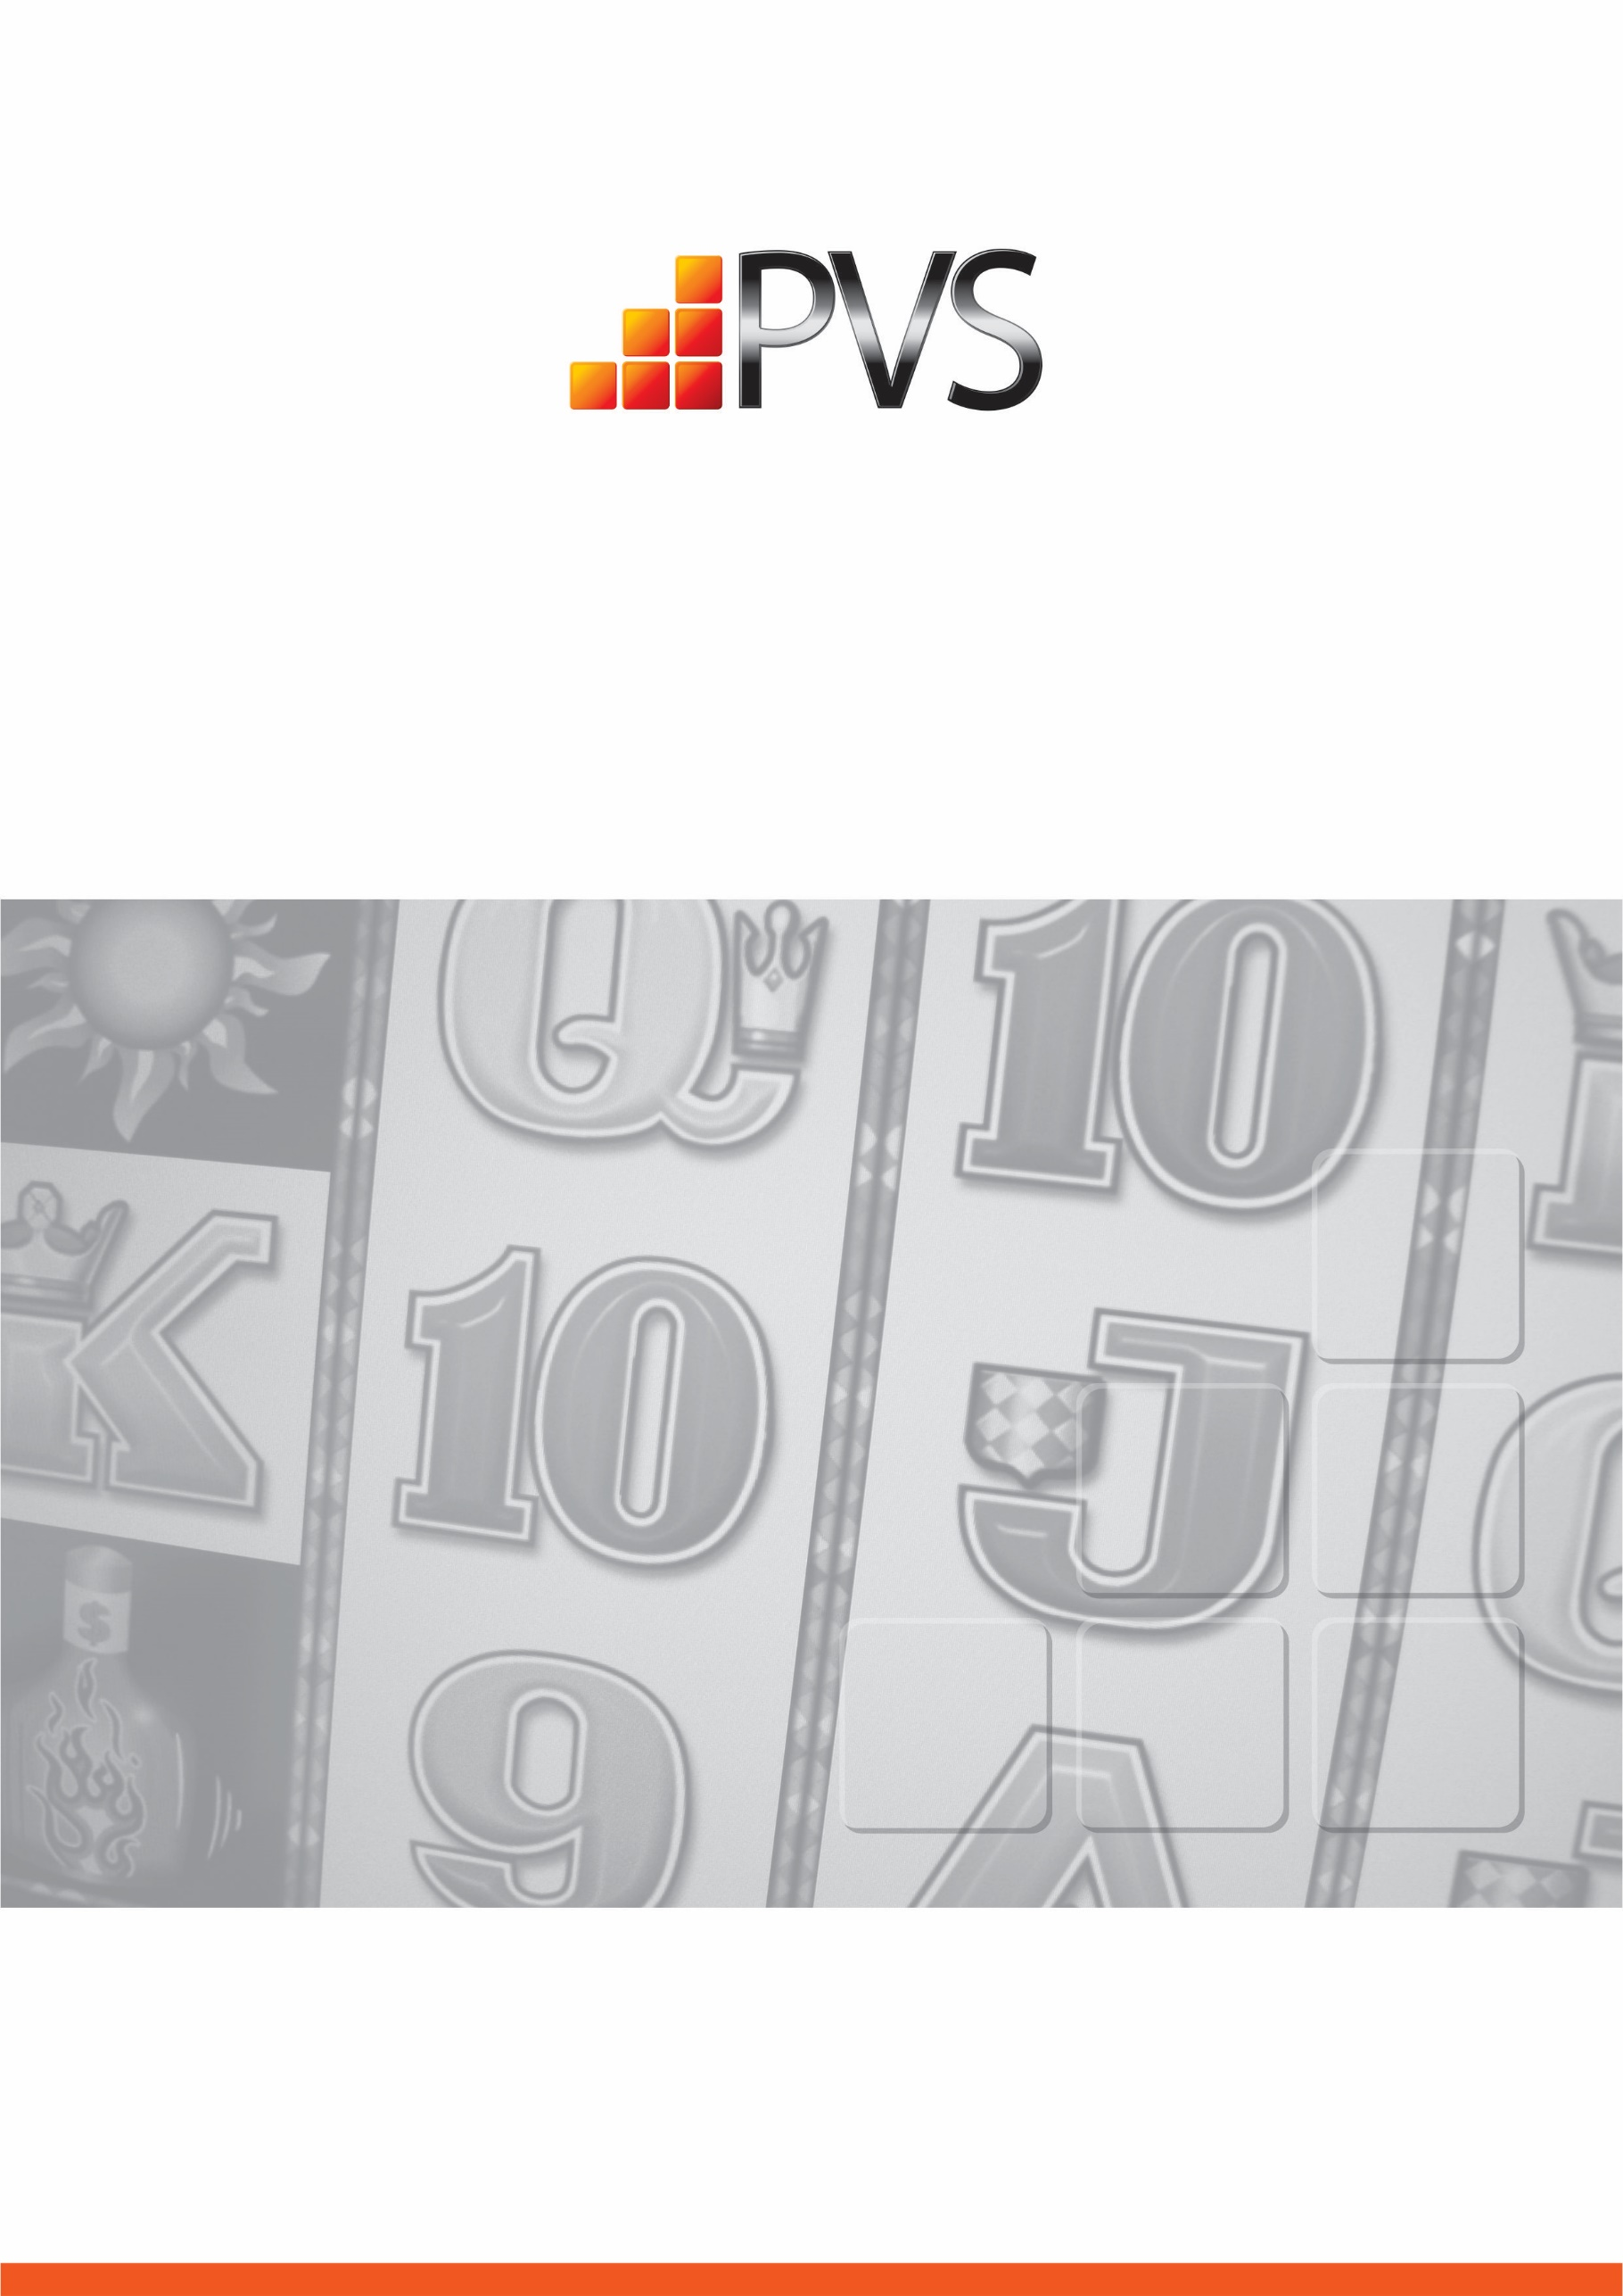
PVS Australia Pty Ltd
Responsible Gambling Code of Conduct
Insert Venue Name Here
August 2020

- Responsible Gambling Message

This venue is committed to providing the highest standards of customer care and responsible gambling. Our Responsible Gambling Code of Conduct describes how we do this.

This venue has a duty to take all reasonable steps to prevent and minimise harm from the operation of gaming machines in this venue, including by monitoring the welfare of gaming machine players, discouraging intensive and prolonged gaming machine play and intervening when a person is displaying behaviour that is consistent with gambling harm.

This message is displayed at the entrance to the gaming room and/or at the cashier’s station in the gaming room.
- Availability of the Code of Conduct

This Code will be made available in written form, including in major community languages, to customers upon request. A sign advising customers of this is displayed at the gaming room entrance or the cashier’s station in the gaming room.

The Code will also be available (in addition to English) in community languages on the venue’s website. (Applies only where the venue has a website)

Languages will include:
- Greek
- Italian
- Vietnamese
- Chinese
- Arabic
- Turkish
- Spanish

- Responsible Gambling Information

This venue displays responsible gambling information in a range of forms, including talkers, brochures, and posters. Responsible gambling information will be made available for patrons throughout the gaming room.

- Interaction with Customers-Communications with Gamblers

This venue is committed to providing consistently high levels of customer service, including being constantly aware of their customers and the venue’s responsibility towards Responsible Gambling.

This venue must ensure that communications with customers do not:

- induce a person to enter or remain in the gaming machine area;

- induce gaming machine play (with the exception of communication that forms part of a lawful loyalty scheme); or

- reinforce or encourage fallacies or misconceptions about gaming machines, including but not limited to:

- telling a person that he or she can make money playing a gaming machine;

- telling a person that a gaming machine or gaming machine jackpot has or has not paid, or that it is due to pay winnings;

- discussing luck or superstitions;

- telling a person that a ‘near miss’ means the gaming machine is about to pay winnings;

- suggesting or encouraging the belief that a spin on a gaming machine is not independent of another spin on that gaming machine;

- suggesting or encouraging the belief that there are strategies that a person can use to win when playing a gaming machine (for example, increasing or decreasing the amount bet per line or number of lines on which a bet is made); or

- telling a person that he or she deserves to win.

This venue must take reasonable steps to ensure that communications with customers discourage intensive and prolonged gaming machine play.

With the exception of EFTPOS signage, this venue must not induce a person to:
- withdraw money, or withdraw more money, from a cash facility; or

- leave the approved venue to obtain money, or obtain more money, to enable that person to play, or to continue to play, a gaming machine.

This venue may however direct a person to a cash facility when requested to do so by a customer.

- Interaction with customers – Signs of Distress

This venue must take all reasonable steps to ensure the gaming machine area and entrances to the gaming machine area are monitored at all times gaming machines are available for gaming.

This venue must take all reasonable steps to ensure that customers in the gaming machine area are regularly observed to monitor behaviour that is consistent with gambling harm.

This venue must not encourage or induce a person to engage in intensive or prolonged gaming machine play.

Staff at this venue are expected to ask a person to take a break away from the gaming machine area where an interaction has occurred and that interaction has determined that the person is angry while gaming or has requested assistance as a consequence of their gaming.

Staff at this venue are expected to interact with a person who has been observed to have been playing gaming machines for a prolonged period without a break and ask that person to take a break away from the gaming machine area.

Staff at this venue are expected to interact with a person who:

- has been asked to take a break and refuses to take a break away from the gaming machine area;

- plays multiple gaming machines simultaneously; or

- reserves a gaming machine in order to play another gaming machine.

A person, who approaches a staff member for information about problem gambling services or shows signs of having a problem with their gambling, will be directed to the Responsible Gambling Officer/Gaming Duty Manager for help.

A customer displaying signs of distress or unacceptable behaviour will be approached by a staff member who will offer assistance.
Contacts with customers by the Responsible Gambling Officer are to be recorded in a Responsible Gambling Register.

- Gaming Venue Staff

Staff at this venue are not permitted to gamble, including playing gaming machines, keno, or wagering on their rostered day of work.

Venue management may decide not to permit staff from playing gaming machines at any time.

This venue will reflect their staff gambling policy in the Venue’s Responsible Gambling Policy and Procedures Manual together with a Staff Gambling Policy Statement in the Venue’s Responsible Gambling Register.

This venue must provide information to staff so that they are aware of their increased risk of harm from gambling. This venue will also assist any staff member who indicates they may have a gambling problem by ensuring they are given information about problem gambling and the support services available. The employee’s right to privacy will be respected and any such matters will not be recorded in the register.

- Interaction with Problem Gambling Support Services

This venue is committed to maintaining strong links with local problem gambling support services. This venue is expected to ensure that staff who have day-to-day management of the operation of the venue and responsible gambling officers meet with the venue’s nominated venue support worker at least once every six months. Details of these meetings will be kept in a Responsible Gambling Register.

- The Gambling Environment

This venue must not encourage a person to play multiple gaming machines simultaneously.

This venue must take all reasonable steps to discourage a person from reserving a gaming machine in order to play another gaming machine in the gaming machine area.

During the opening hours of food and beverage facilities outside the gaming machine floor, this venue must ensure that a person can order and be served food and beverage without having to enter the gaming machine area.

This venue may offer a person seated at or playing a gaming machine food or beverage provided it is offered as part of an interaction with that person.

- Responsible Gambling Officer

This venue must nominate Responsible Gambling Officers for this venue.

A Responsible Gambling Officer must be available in the gaming machine area at all times gaming machines are available for gaming.
This venue must display prominently in the gaming machine area a notice advising that a Responsible Gambling Officer is available for assistance at all times.

This venue’s Responsible Gambling Officer must take all reasonable steps to:

- monitor the gaming machine area and ensure compliance with the Act, regulations and this Code;

- ensure that staff record responsible gambling incidents and interventions in the responsible gambling register;

- observe customers who display behaviour that is consistent with gambling harm and provide assistance as necessary;

- provide advice to staff about gambling harm and how to respond to signs of gambling harm: and

- respond to customer enquiries and complaints about the supply of gambling in the approved venue.

A Responsible Gambling Officer must complete prescribed responsible service of gambling training, if any.

- Responsible Gambling Register

This venue must establish and maintain a responsible gambling register and must ensure that details of all responsible gambling incidents and interventions are recorded in this register, including:
- date and time the incident occurred;

- details of the incident;

- details of the intervention made in response to the incident;

- details of the customer’s response to the intervention, if known

- date and time the entry was recorded in the responsible gambling register; and

- the name of the individual if this is provided voluntarily by that individual.

In accordance with the Privacy Act 1988, the responsible gambling register will be held in a secure location within the venue and will only be accessible to Victoria Police and VCGLR venue staff, inspectors.

This venue must retain the information in the responsible gambling register for not less than six months from the day it was recorded in the responsible gambling register.

This venue must provide a copy of the responsible gambling register to the Victorian Commission for Gambling and Liquor Regulation on request.

This venue may provide information in the responsible gambling register to a Venue Support Worker for training and development purposes provided that the information does not include the name or identifying characteristics of any person.

- Customer Complaints

A customer with a complaint about the operation of this Code of Conduct should make it in writing directly to the venue management. All complaints will be checked by the Venue Manager to make sure that they are about the operation of this Code. Complaints about customer service or machine operations should go directly to the Venue Manager/staff on duty. Venue staff will assist customers with this process if asked.
Complaints will be investigated sensitively and as soon as possible. Complaints will be resolved in the following way:
- all complaints will be acknowledged promptly;

- if it is decided not to investigate the complaint as it does not relate to the operation of the Code, you will be informed of the reasons;

- during the investigation of your complaint the Venue Manager may seek information from the staff member concerned on the subject of the complaint;

- the Venue Manager will seek to establish whether you have been treated reasonably and in accordance with the Responsible Gambling Code of Conduct;

- if your complaint is substantiated, the Venue Manager will inform you of the action that is to be taken to remedy the problem;

- you will always be informed of the outcome of your complaint;

- complaint details will be maintained in the Responsible Gambling Register;

- information about the complaints will be provided to the VCGLR if requested.

If a complaint cannot be resolved at the venue it goes for resolution to the Institute of Arbitrators and Mediators Australia (IAMA). Either party involved in the complaint may contact the IAMA. To initiate a complaint either party can go to IAMA’s web site (www.iama.org.au), download a Dispute Resolver form, and then submit this completed form with the relevant fee to the IAMA. The mediator / arbitrator will then contact both parties to facilitate a resolution. These forms are also available at this venue.
Note: Complaints sent to this independent body for resolution may be expensive. All parties are urged to attempt to resolve the matter at the venue level before going to professional mediation.
Documentation regarding all complaints (both valid and invalid) against the Code must be maintained in the Responsible Gambling Folder / Register for access by the VCGLR as required

- Prohibition of Gambling by Minors

Gambling by minors, including the sale of gambling products and services, is prohibited. Signs are located at every gaming room entrance banning minors from entering the room. All staff share the responsibility for asking for proof of age if they are uncertain whether a customer is at least 18. If relevant verification cannot be produced, the customer must be asked to leave the gaming room.

- Advertising and promotions

Unaddressed advertising of EGM gambling products is prohibited in Victoria.

All non-EGM advertising undertaken by or on behalf of this venue will comply with the advertising Code of Ethics adopted by the Australian Association of National Advertisers.

Each prospective advertisement and promotion will be checked against a checklist developed from the AANA Code of Ethics to ensure compliance.

Further, prior to publishing, management will review all advertising and promotional material to ensure that it will:

- not be false, misleading, or deceptive about odds, prizes, or the chances of winning;

- not be offensive or indecent in nature;

- not create an impression that gambling is a reasonable strategy for financial betterment;

- not promote the consumption of alcohol while purchasing gambling products;

- have the consent of any person identified as winning a prize prior to publication.

- Customer Loyalty Scheme Information
In the event of this venue offering a customer loyalty scheme, a brochure will be made available detailing the appropriate information about the customer loyalty scheme available to participants.
This information will include the rules of the loyalty scheme including how and when rewards accrue, expire, and are redeemed.

Participants will be informed about any benefits they have accrued as part of the loyalty scheme via a written statement or email at least once a year. Self-excluded persons may not join or remain in any loyalty scheme.
- Implementation of the Code

This venue is to ensure that the Code is included in the induction process provided for staff prior to their commencement of employment. At the introduction of the Code the venue is to ensure that all staff currently employed by the venue receives a copy of the Code. The venue will also ensure that PVS Australia Pty Ltd conduct regular Code compliance audits. The frequency of these audits will be at the discretion of the venue and PVS Australia Pty Ltd.
- Review of the Code

This Code is reviewed annually to ensure that it complies with the Gambling Regulation Act and any Ministerial Directions. The operation and effectiveness of the Code for the preceding 12 months will also be reviewed at this time. The review seeks feedback from all relevant stakeholders, including venue staff, customers, and problem gambling support services.
Required changes to the venue’s practices will be noted and then implemented where possible. Any changes will be recorded in the venue’s Responsible Gambling Register.

