Reporting Wholesale Sales Data Guide

June 2022

Table of contents
Table of contents 2
How to register your account 3
How to Associate Liquor Licence 6
How to complete Wholesale Sales Data Questionnaire 7
How to Lodge an Exemption 9
How to Submit Wholesales Data 10

How to register your account
- Register an account in the Wholesale sales data reporting portal using the below link:
https://liquor.vcglr.vic.gov.au/iAlarmWholesalesOnline/.

- Select ‘Register’ in the menu on the left side of the screen.
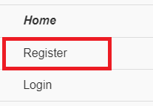

- Fill in your details and choose a password.
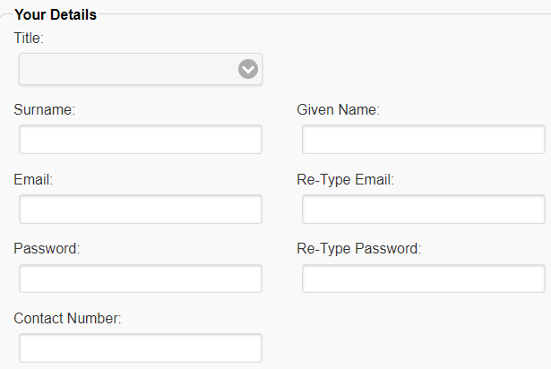
Note: the password must be more than 6 characters and include 1 upper case, 1 lower case and 1 numeric character.
- Select ‘I’m not a robot’

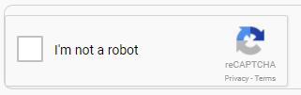

- A window similar to the image below may appear, select the images as indicated in the pop-up window, then click on ‘Verify’
(for example, the below is asking the user to select all images of store fronts)

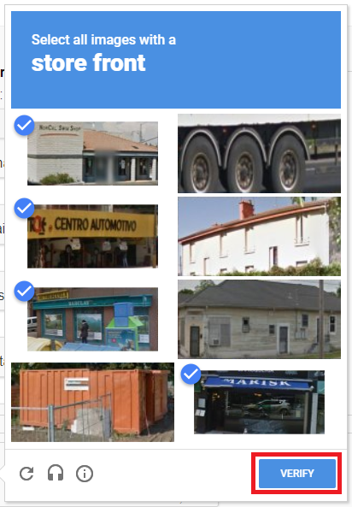

- Once you have completed your details and ‘I’m not a robot’ is ticked (see below image), click on ‘Register’

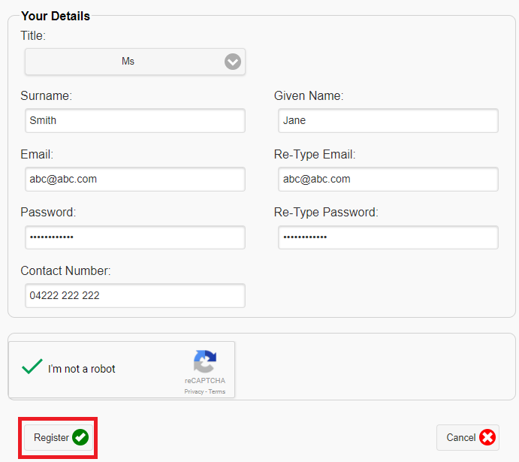

- An email will be sent to your email address titled: User Registration Validation on Wholesales Sales Data Reporting Portal. Click on the validation link in the email to complete your account registration (see below).

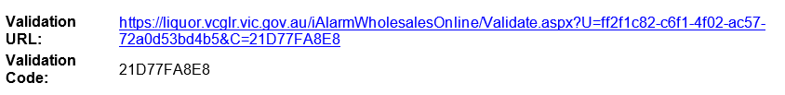

- The link will take you to a login page. Login using your email address and the password you have just created. Ensure you complete the ‘I’m not a robot’ as per steps 4 and 5. Click on ‘Login’ (see below image).
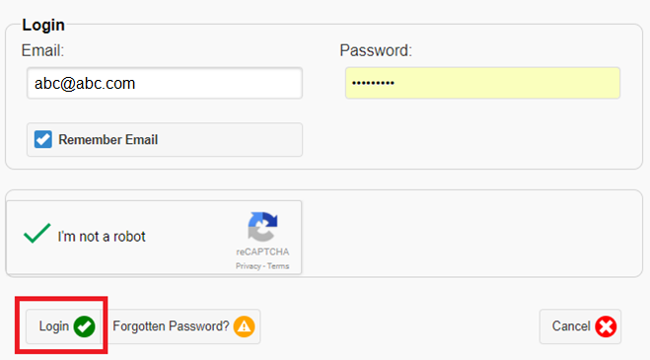

How to Associate Liquor Licence
- Log into the wholesale sales data reporting portal. Click on ‘Add/Associate a Licence’.

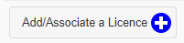

- Enter in the licence number and the postcode of the licence postal address. Complete ‘I’m not a robot’ as per steps 4 and 5 in the above registration instructions. Once these three fields have been completed click on ‘Associate’ as per the below image.

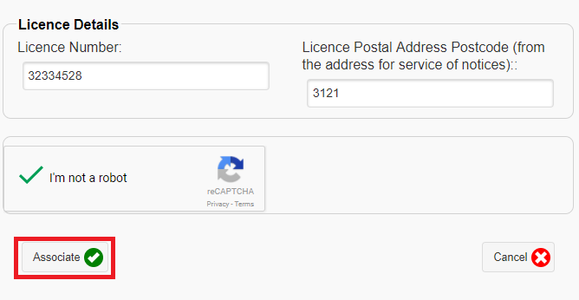

- An email will be sent to your email address with a validation link. Click on the link to associate the licence to your account.

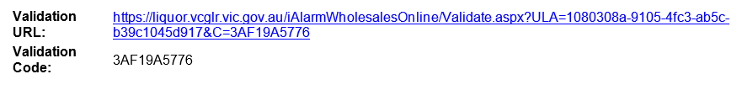

- The licence is now associated to your account and you are ready to complete a questionnaire to determine if you are exempt from reporting or if you need to submit wholesale sales data.

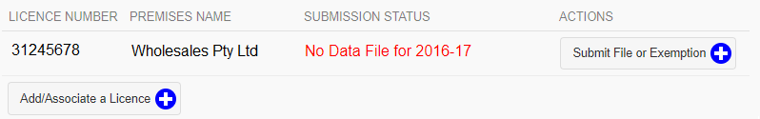

How to complete Wholesale Sales Data Questionnaire
The questionnaire allows you to determine if you are exempt from the reporting requirements or if you are required to report your wholesale sales transactions.

- Login to the Wholesale sales data reporting portal by clicking on ‘Login’ in the menu on the left of the screen. (see below image)

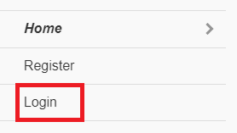

- The link will take you to a login page where you can login using your email address and password. Ensure you complete the ‘I’m not a robot’ as per steps 4 and 5 in the registration instructions. Click on the ‘login’ button as shown in the below image

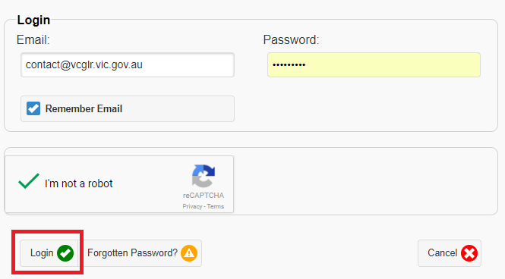

- You will see a list of licenses that are associated to your account. Click on the ‘Submit File or Exemption’ button. (see below image)

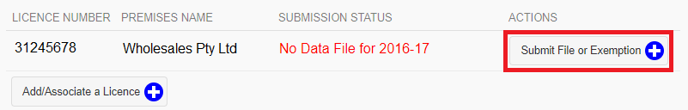

- Answer the questions on this page to determine if you are required to report your wholesale sales transactions or if you are exempt from reporting.

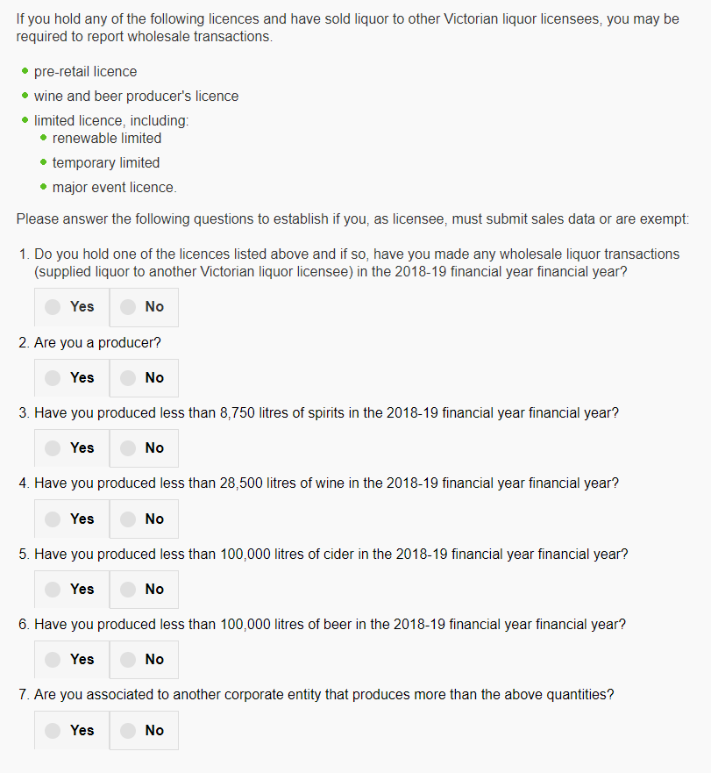

How to Lodge an Exemption

- If the result of the questionnaire is that you are exempt from reporting, the below message will appear. Click on the ‘Lodge As Exempt’ button.

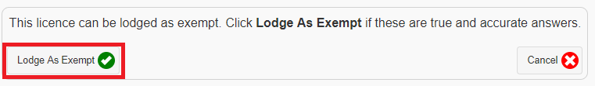

- The submission status of the associated licence will change to ‘Exemption Lodged for 2020-21’. Your exemption has been successfully lodged for reporting period 16-17

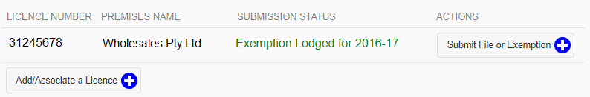

How to Submit Wholesales Data
- If the result of the questionnaire is that you need to report data, the below message will appear.

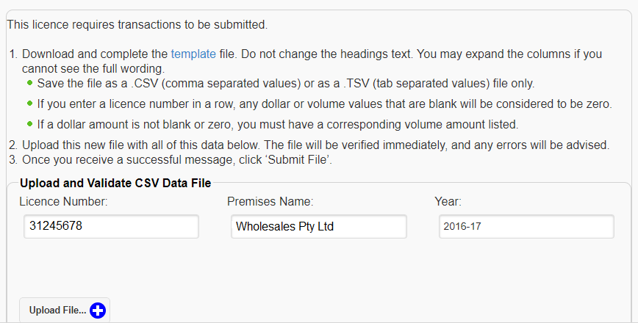

- Download and prepare your CSV or TSV file. More help on creating your file is available on the VGCCC website https://www.vcglr.vic.gov.au/wholesale-liquor-data-reporting.

- Login to the Wholesale sales data reporting portal as per step 8 in the registration instructions.

- Select ‘Submit File or Exemption’ as shown in the below image

- Answer the questionnaire to determine if you need to report wholesale sales data.

- Click on upload file.

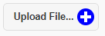

- Double click on the CSV or TSV file you wish to upload.

- Once your file is sucessfully uploaded, you should see the message in the image below, click on ‘Submit File’ to lodge your wholesales data report.

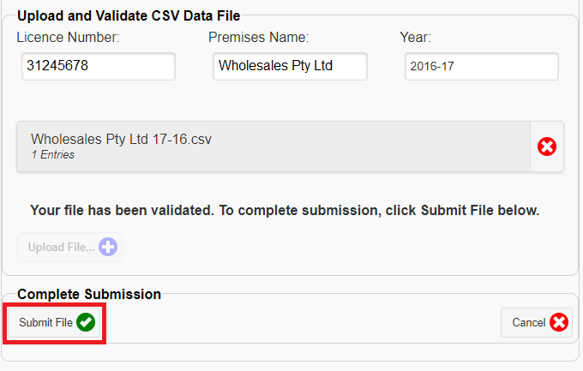

- The data summary page will dispay your current and previous years wholesales data (if applicable). Please check the totals for the current reporting year are as expected and click on the ‘Submit’ button.
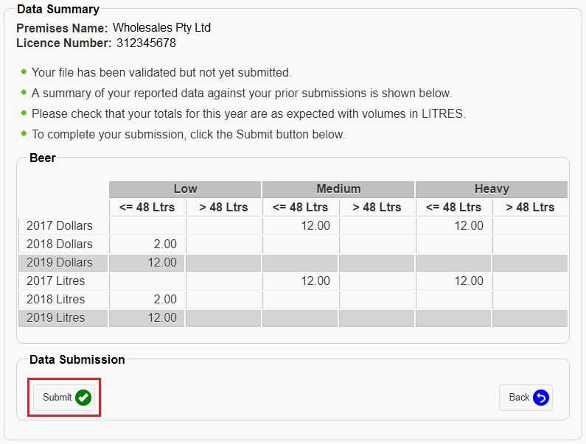
- The submission status of the associated licence will show as ‘Data Submitted for 2020-21’. Your wholesales data has been sucessfully lodged for 2020-21.

