VCGLR Governance Framework V4.0

Table of Contents
VCGLR Governance Framework V4.0 1
1. Introduction 3
1.1 Background 3
1.2 Purpose 3
2. Corporate governance overview 4
3. Corporate governance principles 5
4. Governance practices & implementation 6
4.1 Accountable management 6
4.2 Ethical decision making 8
4.3 Productive stakeholder management 8
4.4 Proficient planning, delivery and robust performance management 9
4.5 Effective management of risk and opportunity 9
4.6 Embedded compliance and internal controls 10
4.7 Responsible information management 10
Appendix 1 VCGLR Governance Control System 12

Introduction

Background
The Victorian Commission for Gambling and Liquor Regulation (VCGLR) is the independent statutory authority that regulates Victoria’s gambling and liquor industries to ensure their integrity and to minimise harm. The VCGLR is responsible for liquor and gambling licensing and undertakes compliance activities to prevent and detect breaches. The VCGLR also informs and educates industry and the public about regulatory practices and requirements.

Purpose
The VCGLR Corporate Governance Framework [the Framework] is designed to provide a sound basis for decision making, to define mechanisms for accountability and to support the achievement of organisational goals.

Corporate governance overview
The VCGLR is managed in a transparent, accountable and responsible way through effective corporate governance which is defined as how the Commission manages the performance of its functions and operations. The following diagram shows how the Framework’s principles and practices enable the Commission to achieve good governance.
Figure 1 VCGLR Corporate Governance Framework Overview
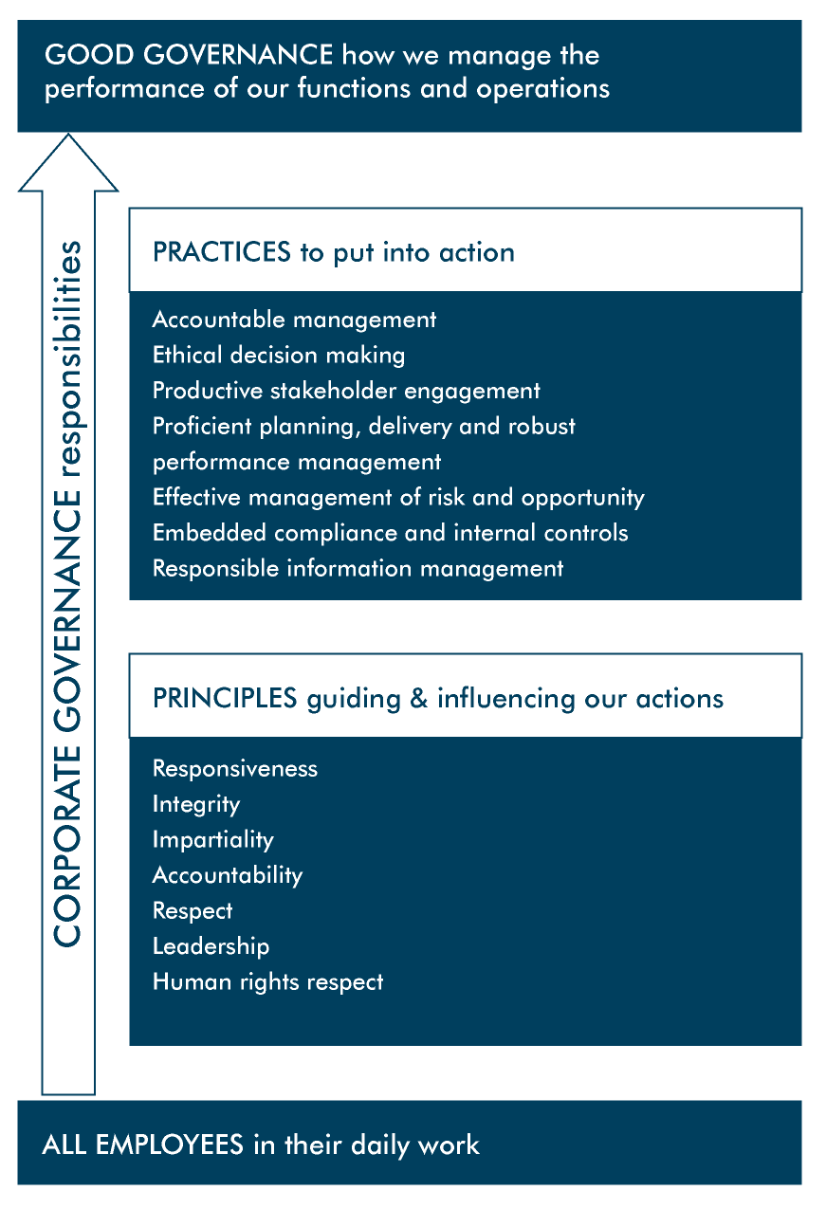

Corporate governance principles
The Public Administration Act 2004 and the Code of Conduct for Victorian Public Sector Employees 2015 (VPS Code of Conduct) provide the basis for the corporate governance principles of the VCGLR. It is the responsibility of all VCGLR employees to ensure that their conduct demonstrates:
- responsiveness by providing frank, impartial and timely advice to the Government and high-quality services to the Victorian community and identifying and promoting best practice
- integrity by being honest, open and transparent in their dealings, using powers responsibly, reporting improper conduct, avoiding any real or apparent conflicts of interest and striving to earn and sustain public trust of a high level
- impartiality by making decisions and providing advice on merit and without bias, caprice, favouritism or self-interest, acting fairly by objectively considering all relevant facts and fair criteria and implementing Government policies and programs equitably
- accountability by working to clear objectives in a transparent manner, accepting responsibility for their decisions and actions, seeking to achieve best use of resources and submitting themselves to appropriate scrutiny
- respect for colleagues, other public officials and members of the Victorian community by treating them fairly and objectively, ensuring freedom from discrimination, harassment and bullying and using their views to improve outcomes on an ongoing basis
- leadership by actively implementing, promoting and supporting these values
- commitment to human rights by providing advice consistent with the Charter of Human Rights and Responsibilities and actively implementing, promoting and supporting human rights.

Governance practices & implementation
Governances practices are implemented through Frameworks which address each governance practice.
Table 1 Governance implementation map
Governance practices | Implementation framework
Accountable management | Governance Framework
Ethical decision making | Integrity Framework
Productive stakeholder engagement | Stakeholder Engagement Framework
Proficient planning, delivery and robust performance management | Planning and Performance Management Framework
Effective management of risk and opportunity | Risk Management Framework
Embedded compliance and internal controls | Legal and Regulatory Compliance Management Framework  Strategic Internal Audit Plan  Financial Management Framework  Procurement/Contract Management Framework  Health & Safety Framework
Responsible information management | Information Security Management Framework  Records Management Framework

The following summarises the control system and a detailed map of the Governance control system map is at Appendix 1.

4.1 Accountable management
The VCGLR is a statutory authority within the Department of Justice and Community Safety (DJ) portfolio. Its Governance Framework reflects its management under the provisions of the Public Administration Act 2004 and the Victorian Commission for Gambling and Liquor Regulation Act 2011.
Governance Structure
The following figure details the VCGLR governance structure.
Figure 2 VCGLR governance structure
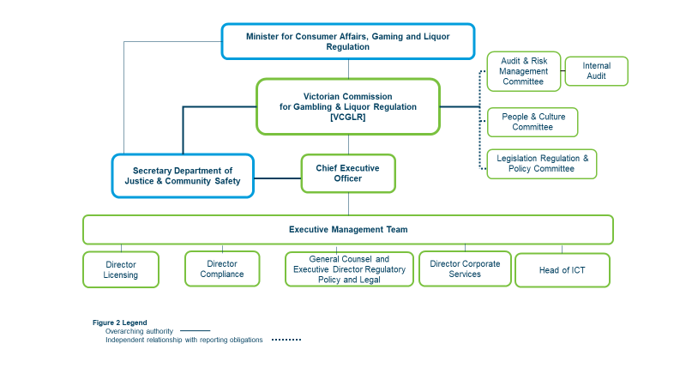
- Portfolio Minister The Commission is accountable to the Minister who in turn is responsible to the Parliament for how the VCGLR exercises its functions. The Commission is obliged to comply with the lawful directions of the Minister as well as the Minister for Finance and the Premier and provide to the Minister all requested information (unless prohibited by law), of any major risks to effective operations or conflict of interest breaches by Commissioners.
- Secretary DJCS The Department has an advisory role to the Minister including advising on the performance of portfolio agencies. Liaison with the Secretary on significant policy, operational and administrative matters is usually conducted by the CEO. However, the Chair, on behalf of the Commission, also liaises directly or leads discussions.
- Commission The role of the Commissioners involves statutory decision making under gambling and liquor laws. The Commission (the Responsible Body) also performs the functions of a ‘board’ of a public sector body and is accountable to the Minister for the VCGLR’s financial management, performance and sustainability.
- Commission Committees The Commission is supported in its role by a number of advisory Committees which report directly to it.
  - Audit and Risk Management Committee (ARMC) established in accordance with the 2018 Directions under the Financial Management Act 1994. The Committee assists the Commission in reviewing the effectiveness of financial management, internal and external audit activities, risk management, compliance requirements and the effectiveness of the internal control environment. The VCGLR maintains an independent and outsourced Internal Audit function which is accountable to the ARMC.
  - People and Culture (P&C) Committee advises the Commission on the development of P&C practices that are legally compliant, aligned with VCGLR strategic priorities and assists the Chair in the role of public service body head.
  - Legislation, Regulation and Policy (LRP) Committee advises the Commission on legislation, regulation and policy matters to assist the Commission to effectively fulfil its regulatory obligations and improve the way it regulates.
- Chief Executive Officer (CEO) The role of the CEO is to manage the day to day activities of the VCGLR and to be responsible to the Commission for overall performance.
- Executive The Commission delegates general responsibility for the operations and management of the VCGLR to the CEO and the Executive. They are accountable to the Commission and fulfil this responsibility through the provision of reports, briefings and presentations to the Commission on a regular basis.
Charters
- Roles and responsibilities are clearly defined in a set of charters for the Commission and its Committees, Internal Audit and the Executive.
Delegations
- The Commission exercises its powers under its establishing legislation, through delegations of some its powers, duties and functions to a single Commissioner or group of Commissioners. The Commission also delegates operational approvals under gambling and liquor regulation to various positions within the organisation.
- The Commission establishes and maintains authorisations covering the creation of financial obligations.
- The VCGLR Chair has employment powers conferred on him/her by enabling legislations and makes employment delegations to particular positions within the organisation. Registers and instruments which document these delegations are reviewed at least annually.
Organisational structure
- The VCGLR undertakes regular reviews of its organisational structure to ensure that it is aligned with its strategic priorities. The organisational chart has clear reporting lines and is supported with position descriptions which are reviewed annually.

4.2 Ethical decision making
As the VCGLR is responsible for ensuring high standards of integrity and probity in the conduct of the industries it regulates, it is critical that its own operations are conducted transparently and with the highest standard of accountability, integrity and probity. The VCGLR Integrity Framework provides an integrated governance approach to enhancing integrity within the VCGLR and exposing and preventing corruption and fraud.
- Ethical standards are defined in codes of conduct and the VCGLR values statement.
- The integrity policy framework provides a comprehensive platform to support the culture of integrity.
- Culture support activities encourage staff to accept personal responsibility for behaving according to VCGLR values and in the public interest and includes an annual culture survey, the Workplace Culture Committee and a rewards and recognition program.
- Ethical compliance certification of compliance with corporate policies and the VPS Code of Conduct by employees annually.
- Fraud and corruption risk management practices take an organisational wide approach to manage the integrity risk profile.
- Fraud and corruption prevention measures include supplier vetting, protected information declarations, client and community awareness program, the Fraud and Corruption Control Policy and the annual Integrity Framework Implementation Plan.
- There is central oversight and high-level ownership for misconduct, corruption, fraud and theft resistance.
- Commitment by the Executive and line management is embedded in performance development plans.
- Fraud and corruption detection is encompassed into the existing internal control and assurance programs and include audits by the Victorian Auditor-General’s Office (VAGO) and the Internal Auditors.
- The fraud and corruption response approach is governed by processes for reporting and investigating misconduct.

4.3 Productive stakeholder management
The Stakeholder Engagement Framework establishes the VCGLR’s approach to stakeholder management. It is supported by the annual VCGLR Stakeholder Engagement Strategy which details the VCGLR’s key stakeholders and key activities. The framework and strategy are augmented by communication policies and guidelines, periodic industry surveys, customer service standards and organisational complaints management processes.

4.4 Proficient planning, delivery and robust performance management
The Planning and Performance Management Framework ensures effective operations and efficient use of resources through a comprehensive strategic planning process which includes risk and opportunity assessment.
- Environmental scanning is conducted.
- The three-year Corporate Plan sets the long-term direction of the organisation and details the key priorities for the coming three years and the annual business planning process develops initiatives to deliver against each priority.
- An integrated and cascading set of Plans and Key Performance Indicators comprising the annual Business Plan, Divisional Plans and Performance Development Plans (PDP) are formulated.
- The Workforce Strategy with its focus on leadership, culture and capability, ensures a skilled workforce at all levels is maintained and developed.
- The ICT strategy ensures that the technology capability of the organisation keeps pace with change and provides the ICT infrastructure and tools consistent with the needs of a modern regulator.
- The annual budget and three-year forward estimates support delivery and efficient resource use aligned with organisational objectives.
- Management information and accounting systems enable review of financial and non-financial performance against budgets and its plans.

4.5 Effective management of risk and opportunity
To achieve its outcomes and outputs efficiently and effectively, the VCGLR must make decisions that involve some degree of risk. The VCGLR has implemented a Risk Management Framework which sets out the arrangements for designing, implementing, monitoring, reviewing and continuously improving the risk management framework. It is consistent with the applicable Australian Standard and is designed to meet the mandatory requirements of the Victorian Government Risk Management Framework (VGRMF).
- The annual VCGLR Risk Management Plan is an organisation-wide plan outlining the road map for the progressive design, implementation and the enhancement of risk management and is evaluated annually.
- The risk appetite is set annually by the Commission.
- Regular strategic and operational risk assessment and reporting is conducted.
- The risk culture plan supports the development of a positive risk culture.
- There are mechanisms in place for interagency collaboration on shared risks.
- Business continuity plans including disaster recovery and emergency management plans are reviewed and tested annually.
- VGRMF Compliance is inherent with Directions Compliance which is attested in the VCGLR Annual Report.

4.6 Embedded compliance and internal controls
The VCGLR Legal & Regulatory Compliance Management Framework supports the compliance of the VCGLR with its legal and regulatory obligations to reduce the risk and consequences of compliance failure in the areas of health and safety, governance, financial management, fraud and corruption and information management.
- The VCGLR Control System is subject to continuous improvement. The three year Strategic Internal Audit Plan focusses on those control systems considered higher risk and the core business processes where VCGLR is seeking to improve the internal controls and make processes more efficient.
- The VCGLR Financial Management Framework establishes a system of governance and assurance within the VCGLR to ensure the quality and adequacy of financial management, performance and sustainability. It is consistent with the 2018 Directions of the Financial Management Act 1994. Financial management roles and responsibilities and the governance structure are defined. Policies and procedures in relation to financial administration and management comply with relevant legislation and regulation, professional accounting pronouncements, government policy and standard accounting practice. The Financial Management Plan ensures compliance with the Directions. The financial statements are audited by VAGO. An internal assurance process with respect to financial statements, budget and financial performance management and financial management compliance is conducted annually with the Audit and Risk Management Committee. The Annual Report is tabled in Parliament each year and VCGLR’s operations and financial statements are prepared according to the Department of Treasury and Finance (DTF) Model Financial Report.
- The VCGLR Procurement and Contract Management Framework is based on high standards of probity and is consistent with the Victorian Government Purchasing Board (VGPB) principles and guidelines.
- The Health & Safety Framework is compliant with the Occupational Health and Safety Act 2004. It is designed to give the highest level of protection to employees and visitors against risks to their health and safety that is reasonably practicable. The Health and Safety Committee provides oversight. Goals and performance measures are defined and a comprehensive policy framework has been implemented. Risks are assessed, the workplace is inspected and maintained. There is a strategic approach to communication and training. There are procedures for and testing of emergency management and a first aid response capability is supported.

4.7 Responsible information management
To comply with its legal and regulatory compliance requirements for information security protection of the Victorian Protective Data Security Standards (VPDSS) under the Privacy and Data Protection Act 2014 the VCGLR has developed the Information Security Management Framework.
- The Risk Management Framework is used to conduct Security Risk Profile Assessments with oversight provided by the Audit and Risk Management Committee.
- The information assets register maps and values official information to which protective markings are applied along with secure disposal.
- The access management regime to VCGLR data includes physical and logical access arrangements, password controls, on and off boarding procedures and access rights reviews.
- Security obligations are supported by the training/awareness program.
- Information security incident management regime includes policy, plans, incident register and incident response testing.
- Business Continuity Plans manage events that affects the confidentiality, integrity and availability of VCGLR information and are tested annually.
- Third party information security controls over contracts, Memorandum of Understanding (MOU) and information sharing agreements include a risk assessment process, register and information release processes.
- OVIC Information Security Reporting includes incident notification, the bi-annual Protective Data Security Plan and an annual attestation on the progress of VPDSS implementation.
- Personnel security controls include pre-employment screening, probity and police checks and ongoing monitoring to manage people’s suitability and eligibility to access VCGLR data.
- ICT security controls are defined in the ICT Security Policy and address issues including cyber security, ICT assets, vulnerability, change management, communications, media, Standard Operating Environment, system logging and monitoring, emails, network, malware, back up and secure software development.
- Access to office building and work spaces, data centres and communication and storage rooms is managed through physical security controls which include the security plan, scalable physical security measures and out of office and equipment maintenance processes.
Records Management Framework ensures that full and accurate records of VCGLR activities and decisions are created, managed and kept in accordance with the provisions of the Public Records Act 1973. It outlines and encompasses the VCGLR records management policy, strategy and a range of record management processes and procedures (Business Classification Scheme, Access Restrictions Criteria and Disposal/Destruction Policy, Records Disaster Recovery Plan) and is based on legislation and whole of government standards.

Appendix 1 VCGLR Governance Control System

Governance Practice | Implementation | Components
Accountable management | Governance Framework | - Governance structure  - Charters  - Delegations  - Organisational structure
Ethical decision making | Integrity Framework | - Ethical standards  - Integrity policy framework  - Culture support  - Ethical compliance certification  - Fraud & corruption risk management  - Fraud & corruption prevention measures  - Central oversight  - Fraud and corruption detection and response
Productive stakeholder engagement | Stakeholder Engagement Framework | - Stakeholder engagement strategy  - Communication policies and guidelines  - Industry surveys  - Customer service standards  - Organisational complaints management process
Proficient planning, delivery and robust performance management | Planning and Performance Management Framework | - Environmental scanning  - Corporate plan (strategy)  - Cascading business, divisional and PDP Plans  - Workforce strategy  - ICT strategy  - Budgets  - Management information & accounting systems
Effective management of risk and opportunity | Risk Management (RM) Framework | - RM plan & evaluation  - Risk appetite  - Risk profile assessments  - Risk culture plan  - Interagency collaboration mechanisms  - Business continuity management  - Victorian Government Risk Management (VGRMF) compliance
Embedded compliance and internal controls | Legal and Regulatory Compliance Management Framework | - Strategic Internal Audit Plan  - Financial Management Framework  - Procurement/contract management framework  - Health and Safety (H&S) framework
Responsible information management. | Information Security Management Framework | - Security risk profile assessments  - Information asset register & protective markings  - Access management regime  - Security obligations training & awareness  - Information security incident management regime  - Third party arrangements  - OVIC reporting  - Personnel security  - Physical security  - ICT security
 | Records Management (RM) Framework | - RM strategy, policy and procedures

Document Panel
Version | V4.0
Approved by Executive on | Scheduled 27/01/21
Approved by Commission on | Scheduled 25/02/21
Document owner: | Governance & Reporting Manager, Corporate Services

