你对你的卖酒执照了解多少？  你充分了解与你的卖酒执照有关的义务、责任和法律吗？  维州赌博及酒类监管委员会每月发布电子版简讯，报导行业内的新闻、最新情况和重大事件。  想要了解最新信息，请点击这里订阅（subscribing here）电子版简讯。  你还可以通过脸书（Facebook）和推特（twitter）了解维州赌博及酒类监管委员会的最新动态。 | 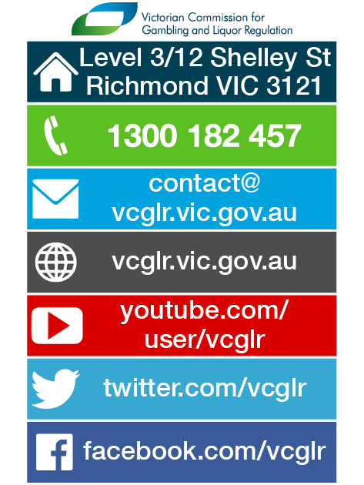
How much do you know about your liquor licence?

How much do you know about your liquor licence?

Are you confident with your knowledge about your obligations, responsibilities and legislation relating to your liquor licence?

The Victorian Commission for Gambling and Liquor Regulation (VCGLR) publishes a monthly electronic newsletter with industry news, updates and events.

Keep up-to-date by subscribing here.

You can also follow the VCGLR on Facebook and twitter.

How much do you know about your liquor licence? Simplified Chinese

